**DATA HW4 – Multi-Region Application**

Submitted By Team: **Data Warriors**

Source Code Repository**: https://github.com/Smitashri/BigDataHW4**

**What is Multi Region Application:**

The Multi-Region Application architecture solution mainly helps us in the demonstration of fault tolerance with easy failover to Backup a region. The solution leverages Amazon simple storage services which is called Amazon S3 Cross-Region replication and Amazon DynamoDB global tables to replicate application data between primary region and secondary region. In order to check if the failover is working fine, a sample photo sharing web application is also deployed in each region to serve as a visual demonstration of the solution’s back end layer.

**Architecture Overview:**

The Multi Region Application architecture utilizes three layers:

1. An API layer built using Node.js running on AWS Lambda and exposed via Amazon API Gateway.
2. A data layer storing customer tickets in DynamoDB.
3. A UI layer built using HTML, Javascript and CSS and hosted directly from AWS S3.

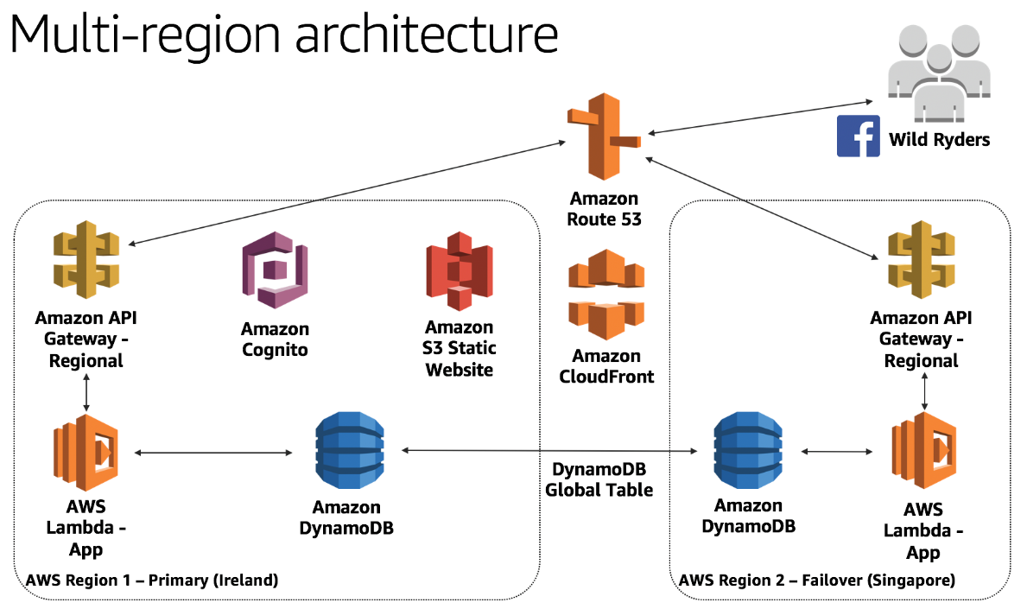

The main moto of this kind of architecture is that the backend components will be replicated to second region so that we can failover in the event of a disaster.

This can be done using different modules namely : [Create AWS Cloud9 Environment](https://github.com/enghwa/MultiRegion-Serverless-Workshop/blob/master/0_Cloud9/README.md), [Build an API layer](https://github.com/enghwa/MultiRegion-Serverless-Workshop/blob/master/1_API/README.md), [Build a UI layer](https://github.com/enghwa/MultiRegion-Serverless-Workshop/blob/master/2_UI/README.md), [Replicate to a second region](https://github.com/enghwa/MultiRegion-Serverless-Workshop/blob/master/3_Route53/README.md), [Test failover](https://github.com/enghwa/MultiRegion-Serverless-Workshop/blob/master/4_Testing/README.md).

As the concept says, we need to select two regions in order to check if the failover is working. Here we have decided to use Ireland (eu-west-1) as the primary region and Singapore(ap-southeast-1) as the secondary region.

**PREREQUISITES:**

Some of the important prerequisites are AWS account, Domain name, AWS Cloud9 for AWS Command Line Interface.

To start the Steps of this Multi Region Application, we will go in the same order of the modules as mentioned earlier.

1. Create AWS Cloud9 Environment:

Initially to create the environment, we need to select the primary region which is Ireland in our case.

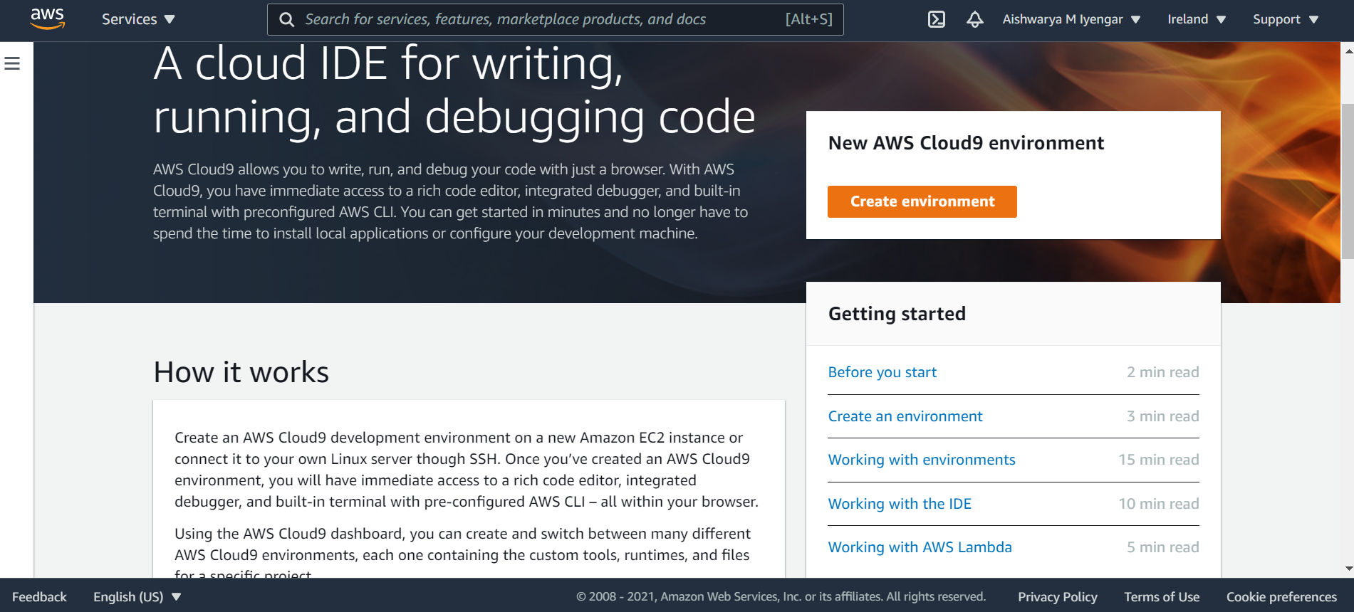

While creating the environment, we give unique name post which we need to do the configuration settings .The name given to our environment is Bigdata_HW4 and configuration as below

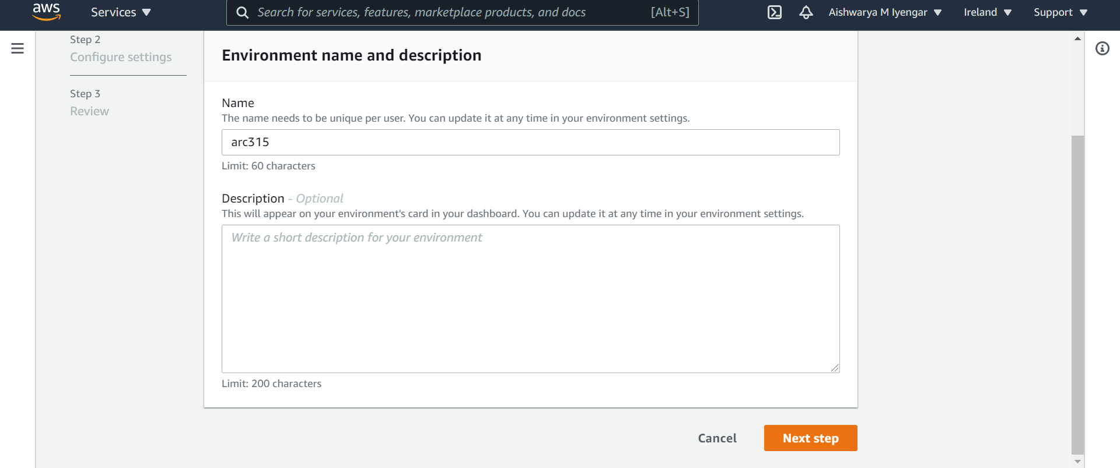

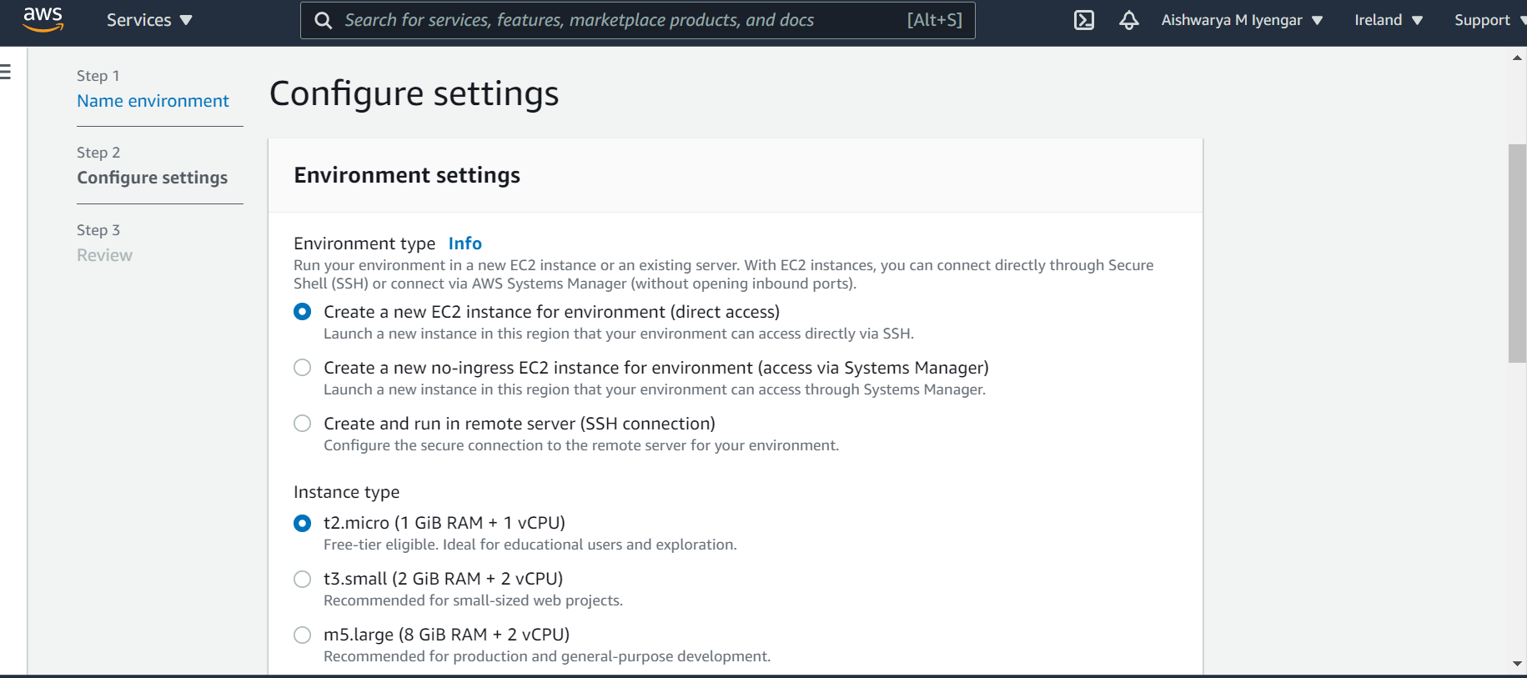

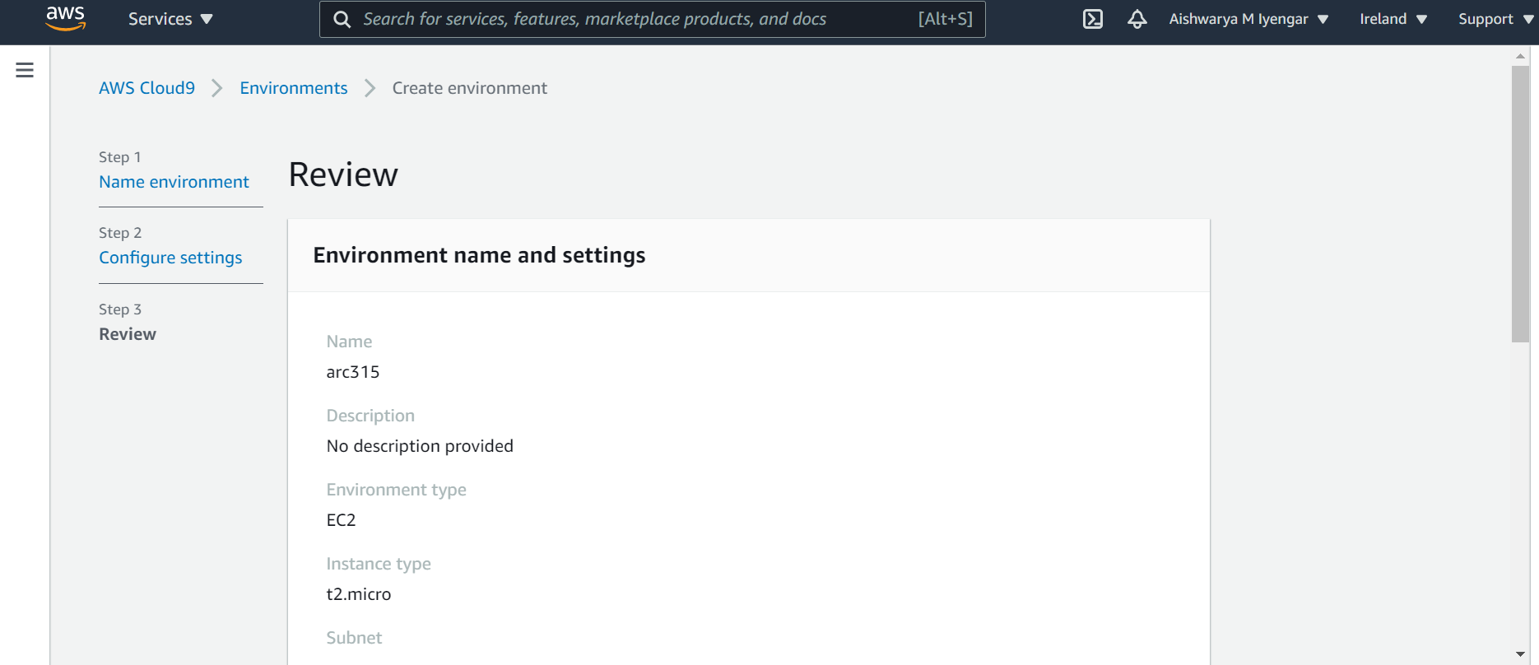

After the creation of the environment, we need to execute the commands in the command prompt.

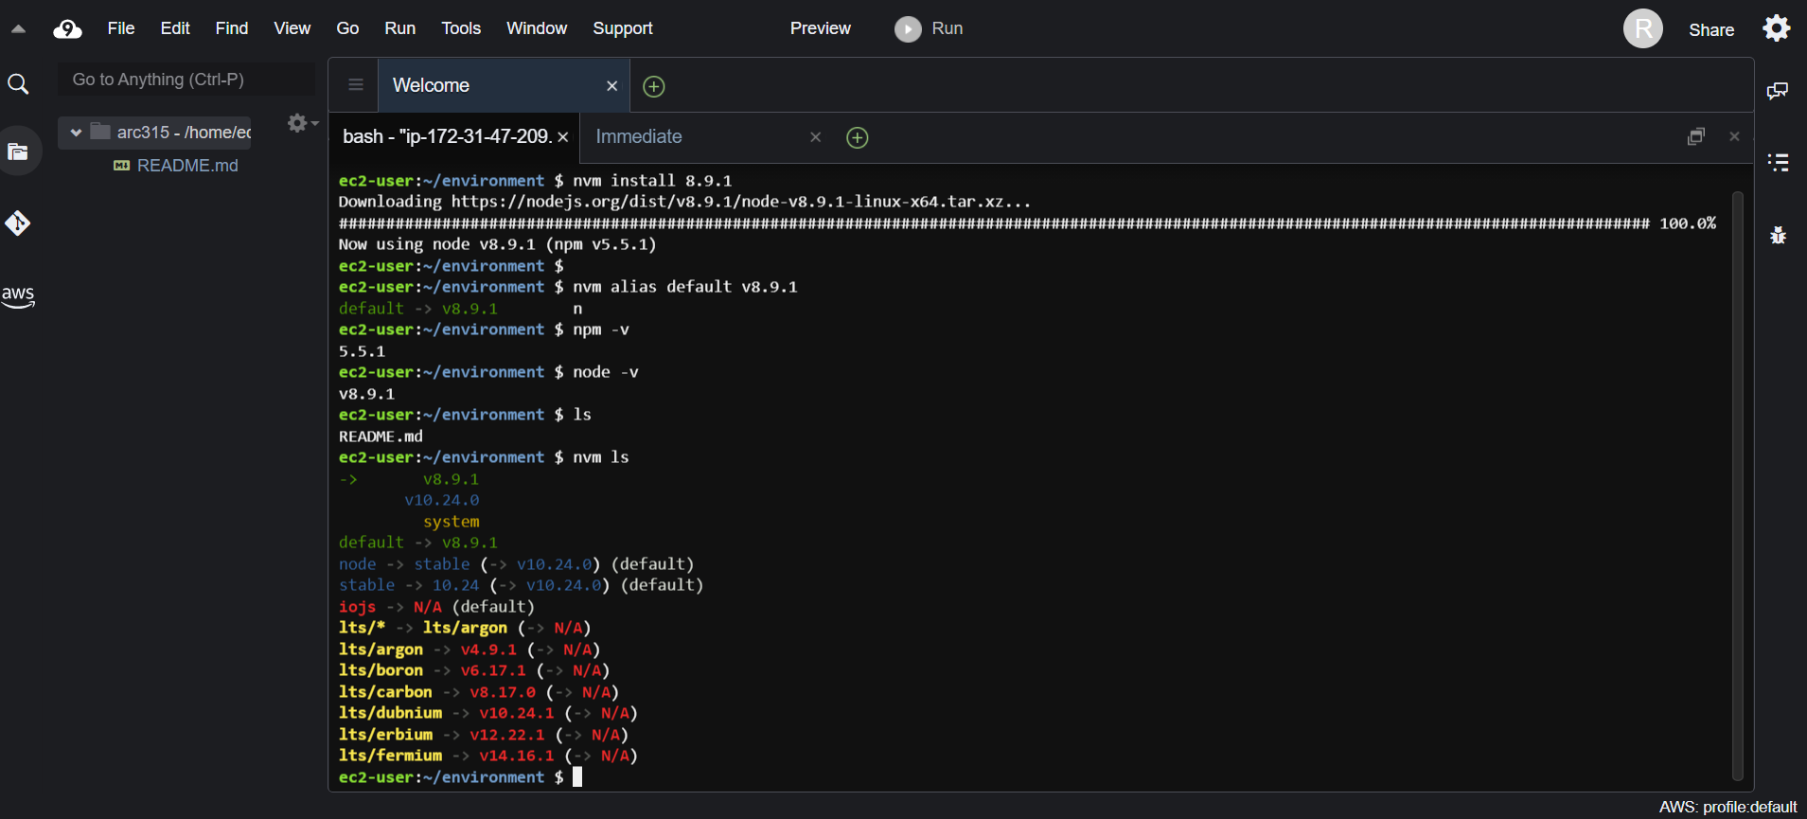

Post the execution of steps, we also clone the project as below:

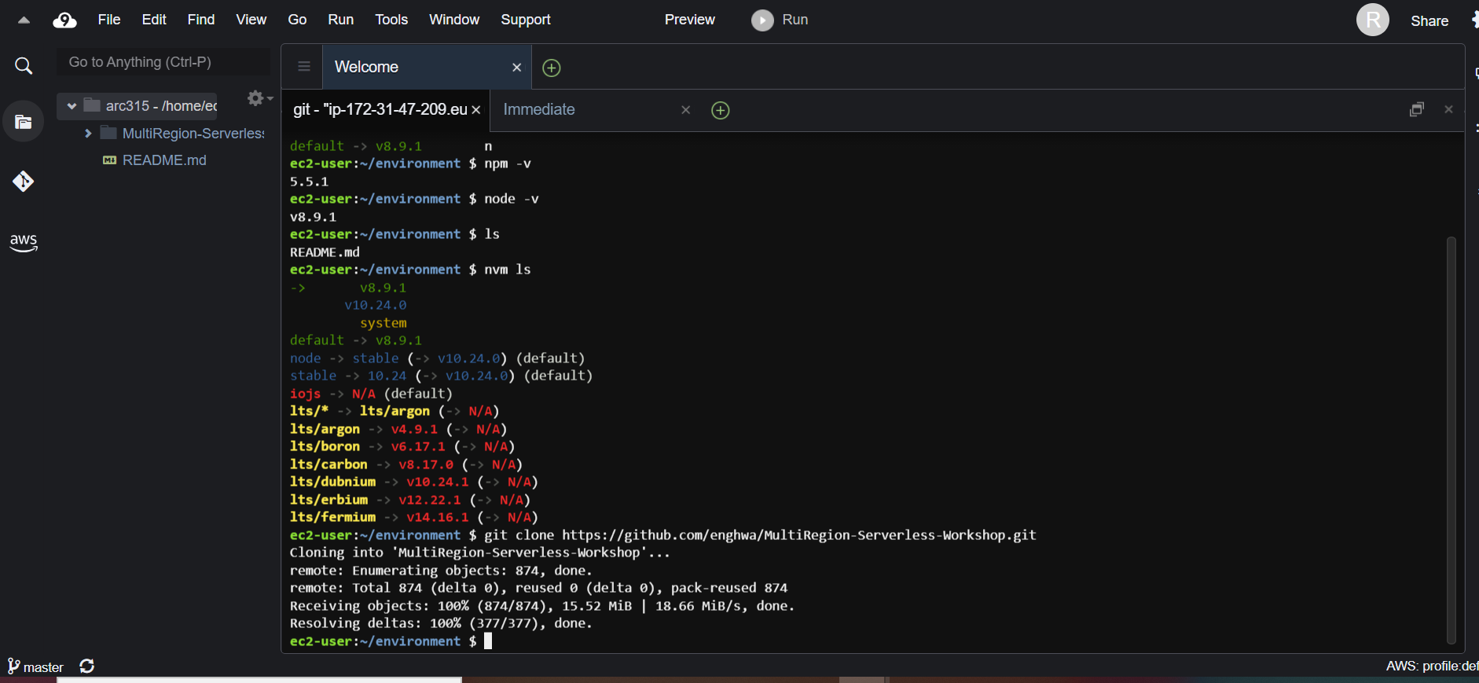

**2. Build an API layer.**

In this modules, we have deployed the backend application components to 2 AWS regions which was opted Ireland and Singapore.

The backend components include 3 AWS Lambda functions, 2 API Gateway Endpoints and DynamoDB Global Table per Region with IAM policies and roles required by these components

The steps which are need to followed as follows:

1. Create the appropriate IAM policies and roles our three AWS Lambda functions
2. Create the required Amazon DynamoDB Global table
3. Create the three AWS Lambda functions (both Ireland and Singapore)
4. Create the Amazon API Gateway for the region you are currently deploying (both Ireland and Singapore)
5. Testing to ensure our backend components are all working as expected.

**1] Firstly, Creating the policy TicketGetPolicy** 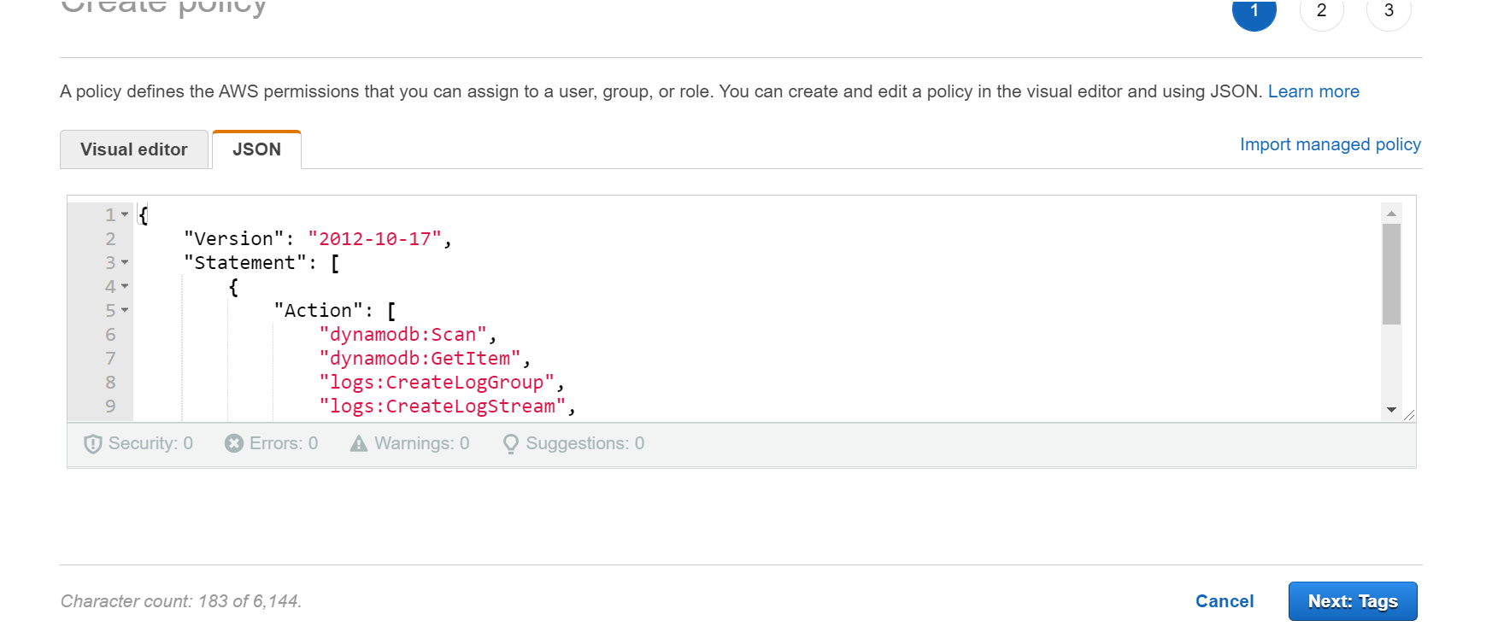

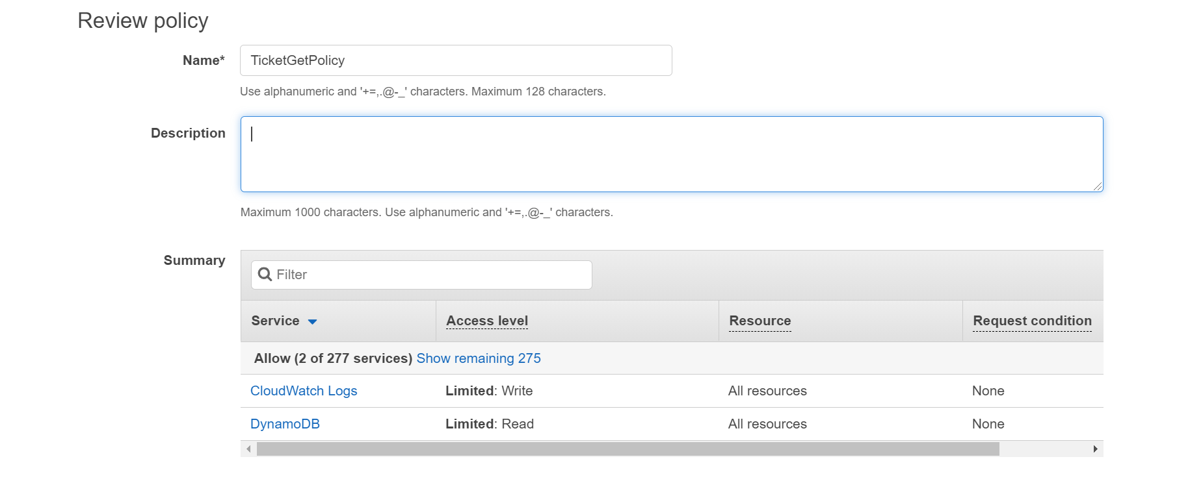

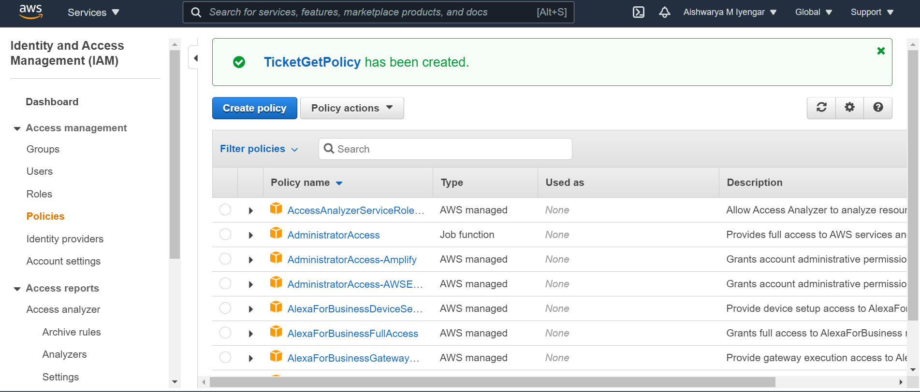

**Creating the policy** [**TicketPostPolicy**](https://github.com/enghwa/MultiRegion-Serverless-Workshop/blob/master/1_API/wild-rydes-dynamodb-post.json)

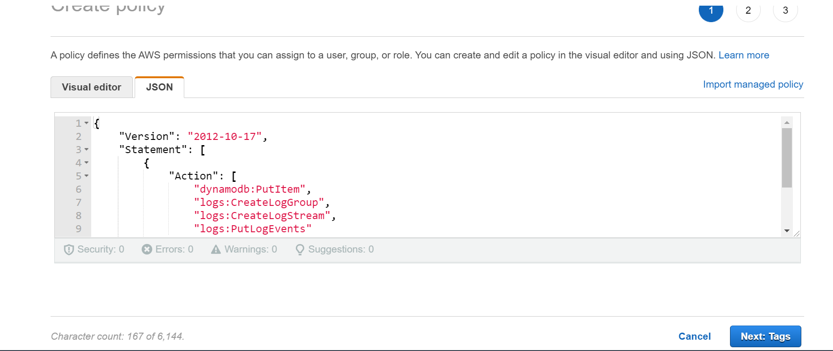

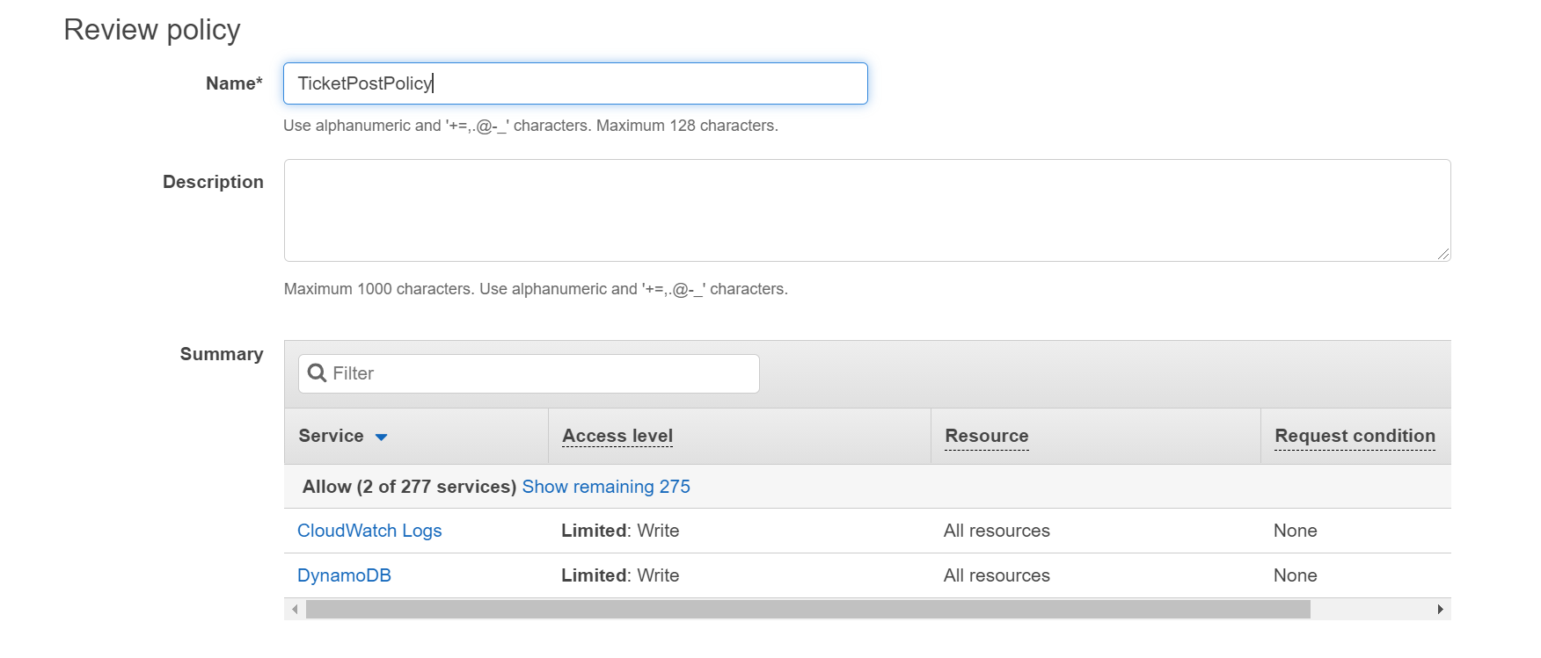

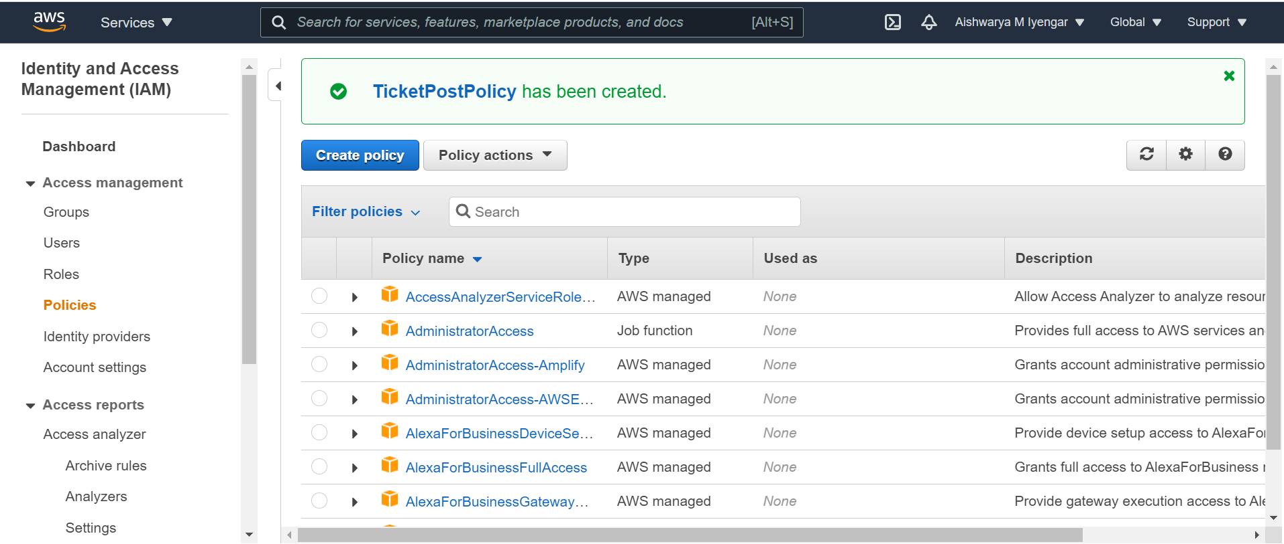

**We need to create the roles for the policies now.**

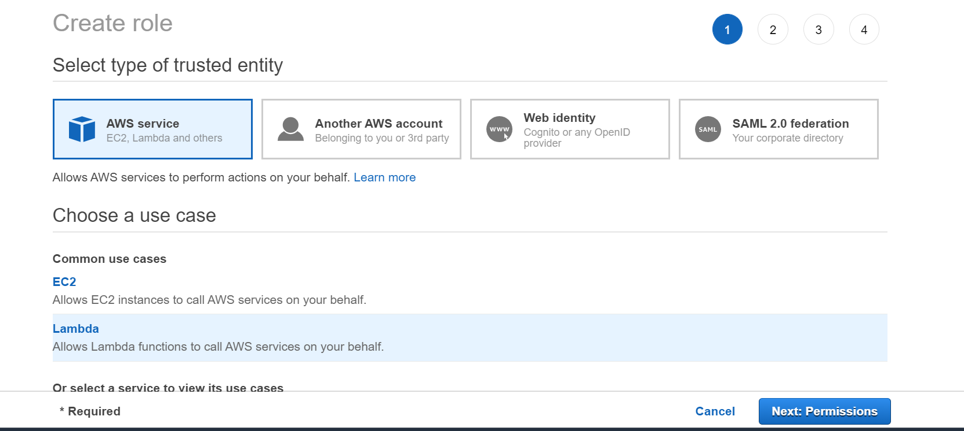

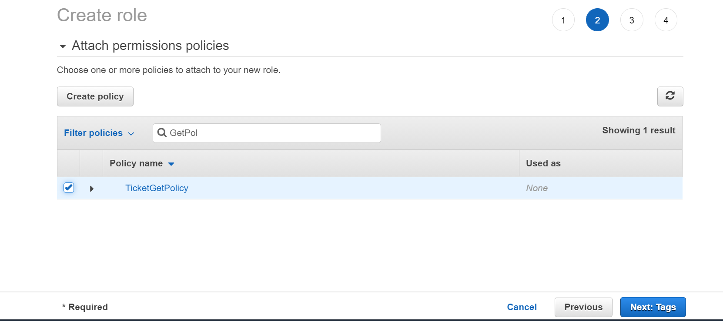

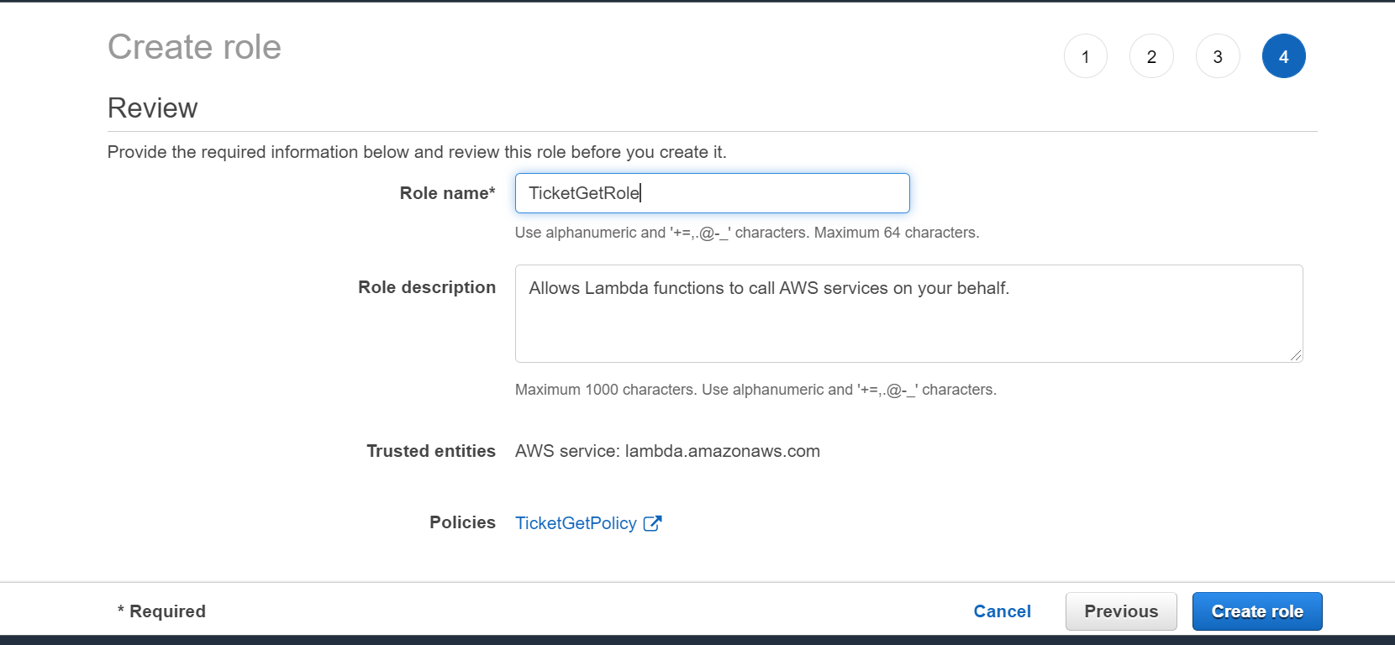

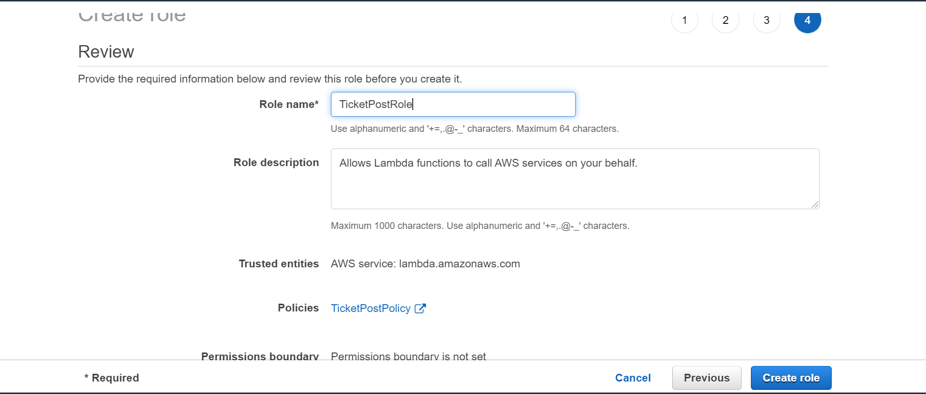

**2] Creating the required Amazon DynamoDB Global table.**

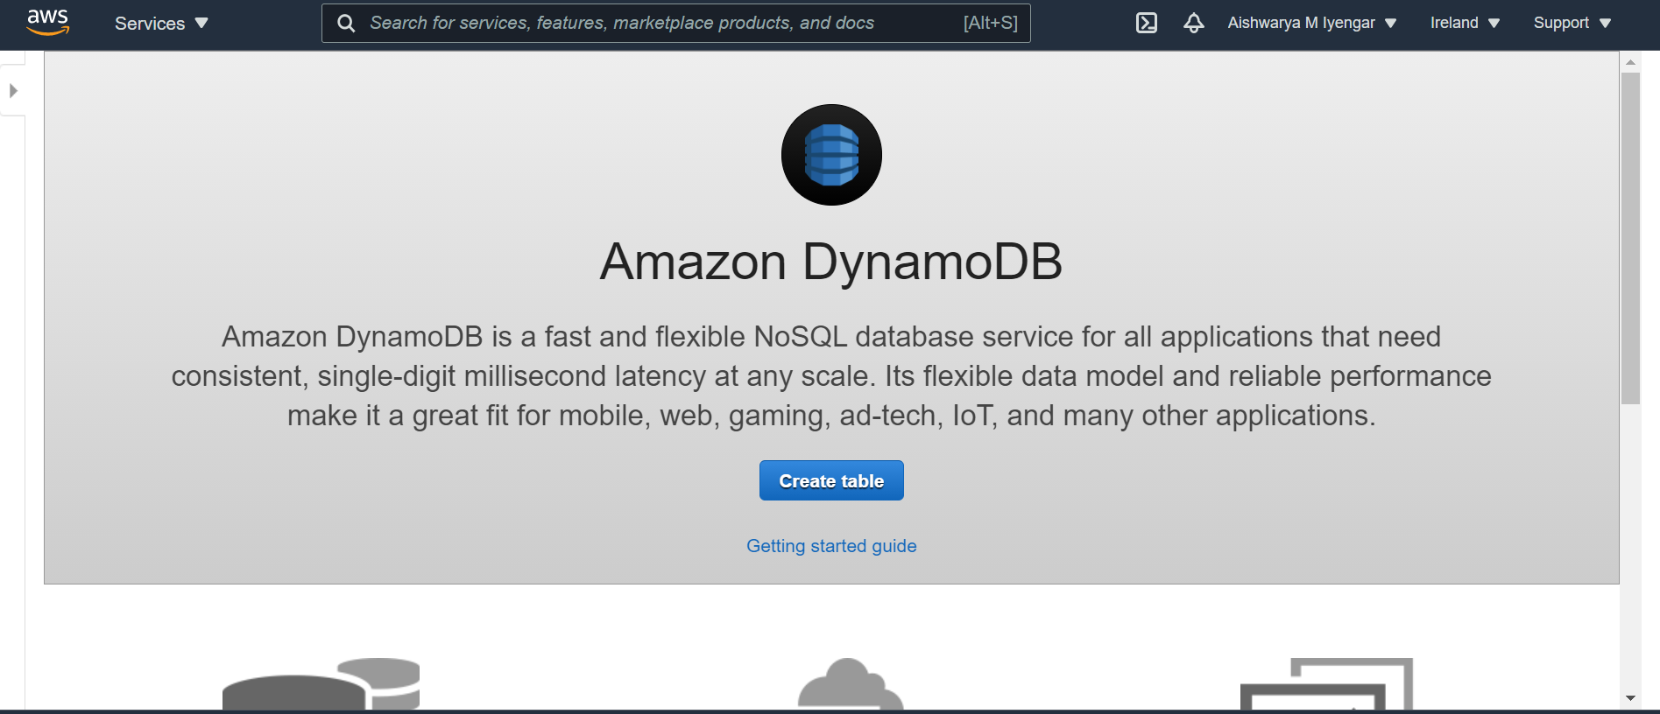

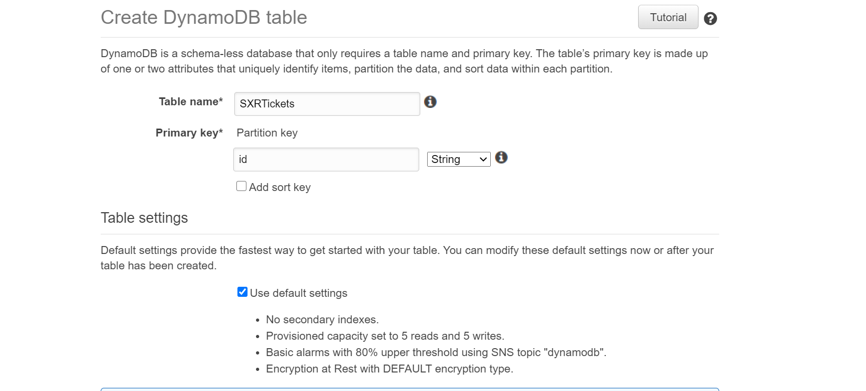

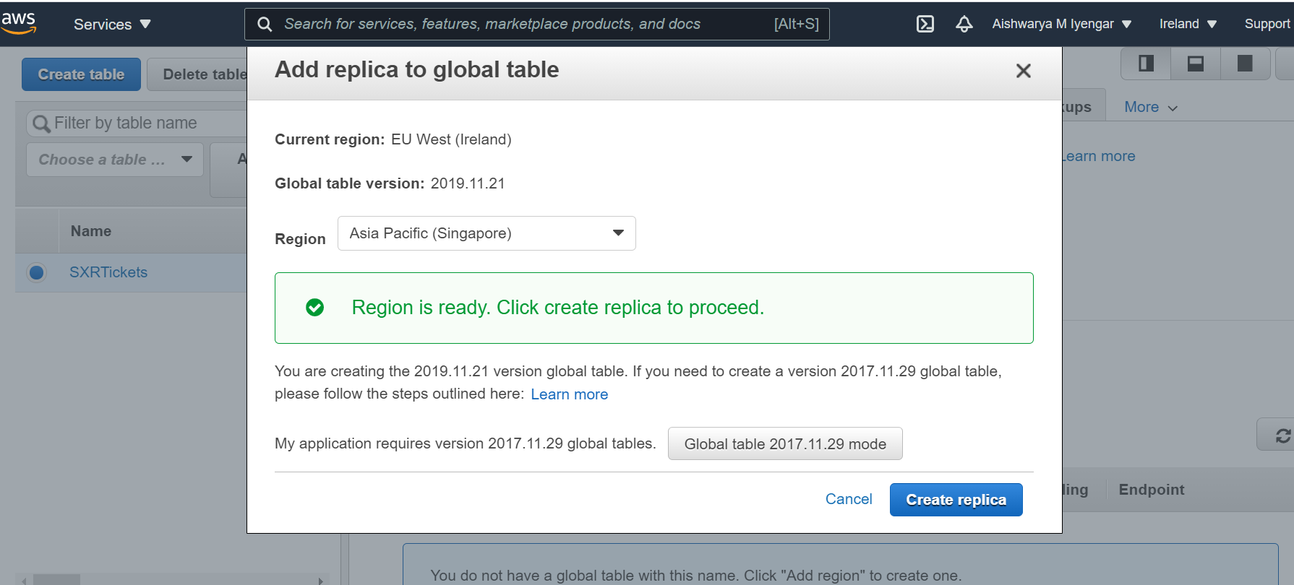

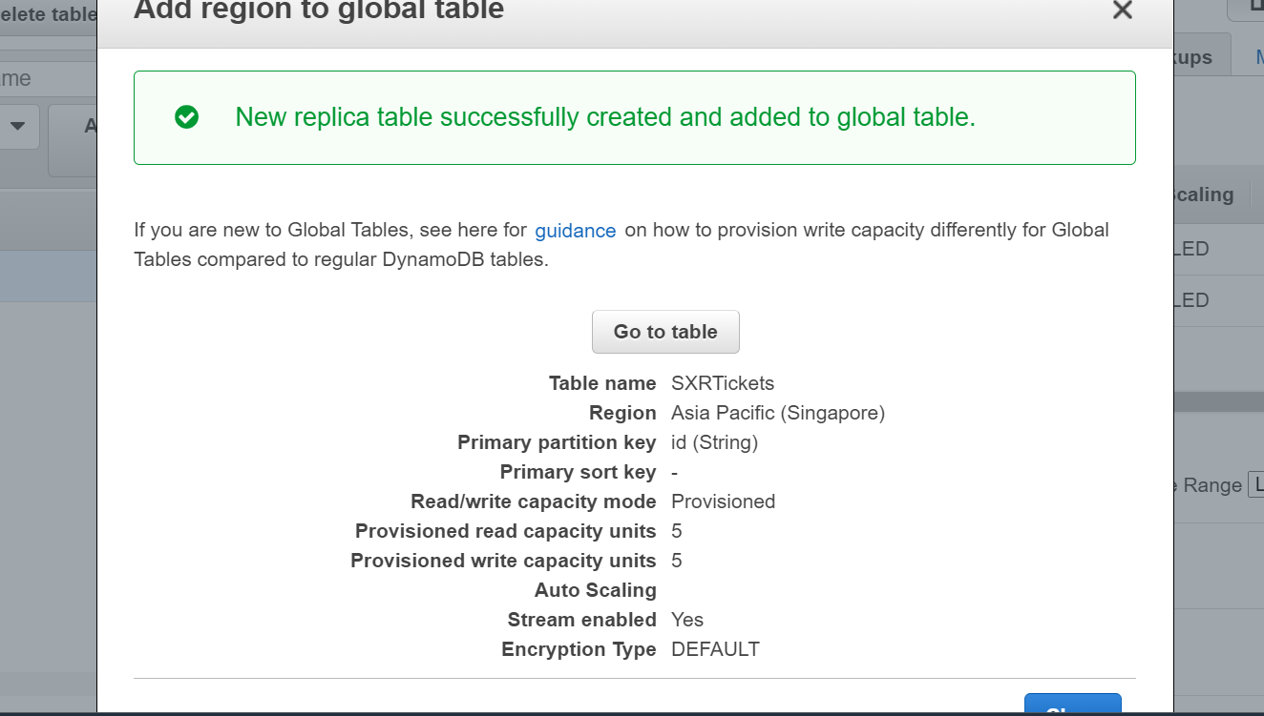  
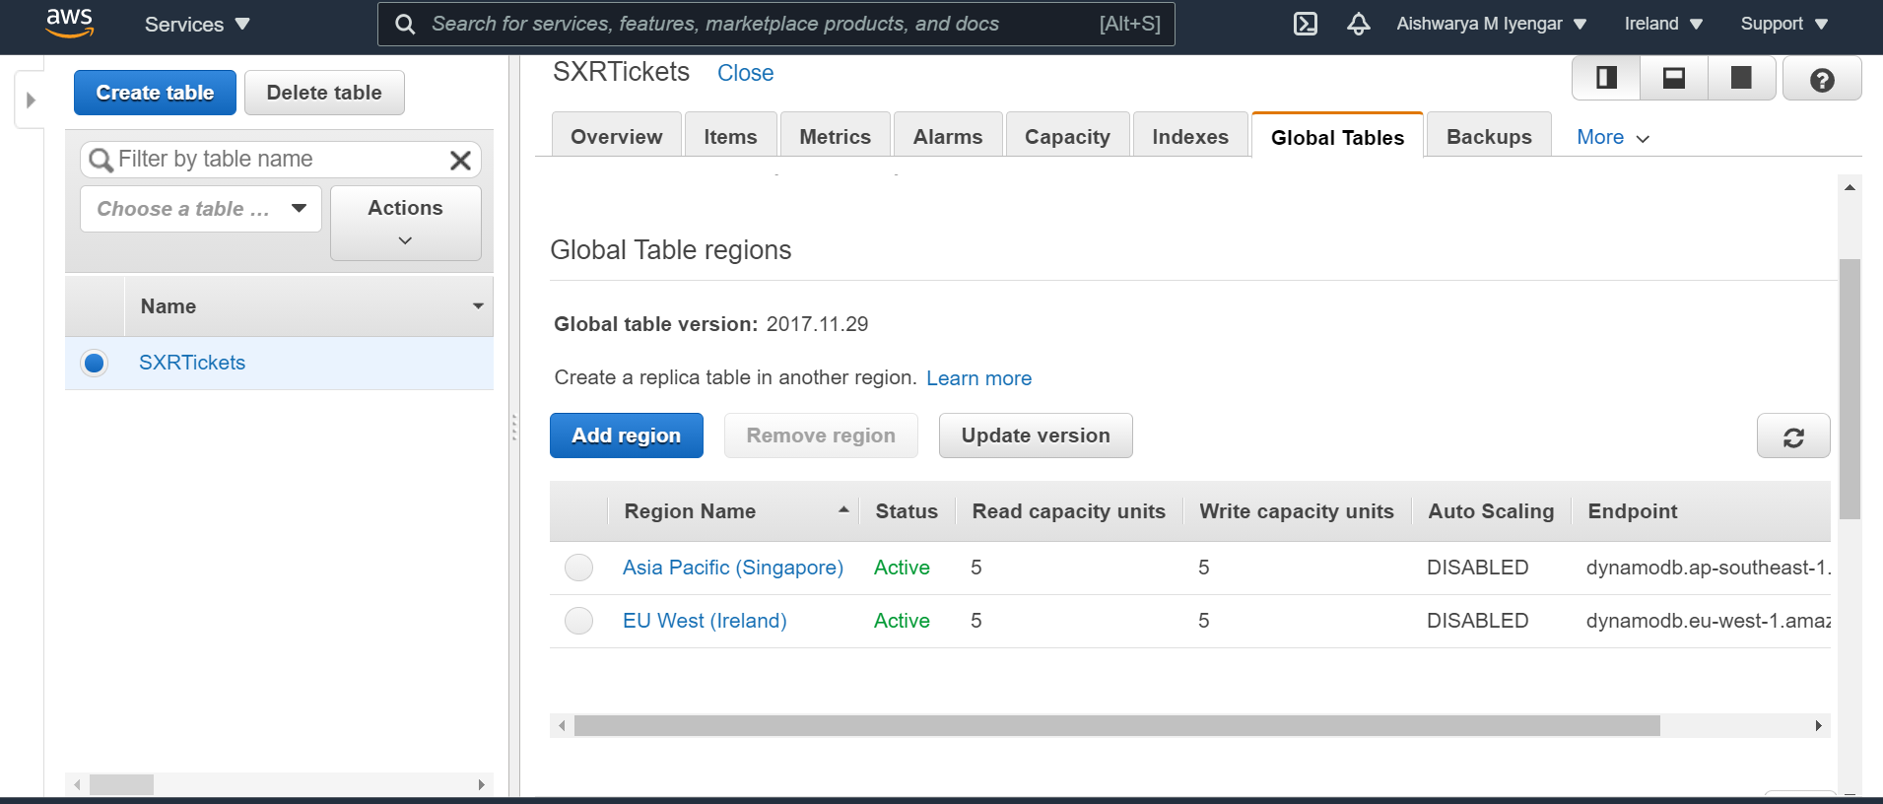

**3] Creating three lambda function:**

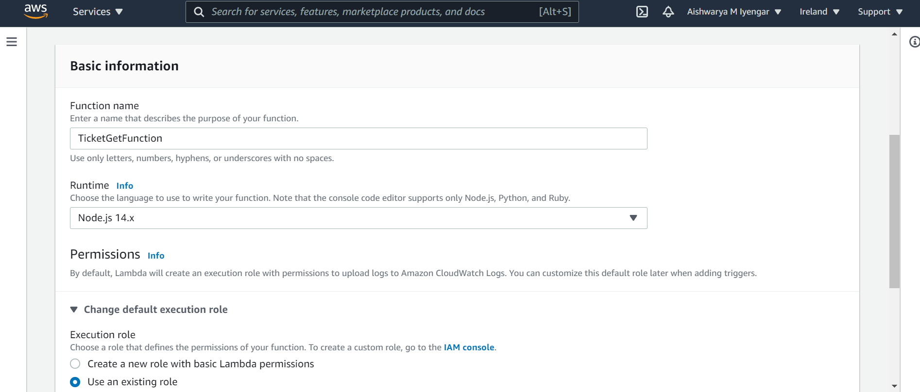

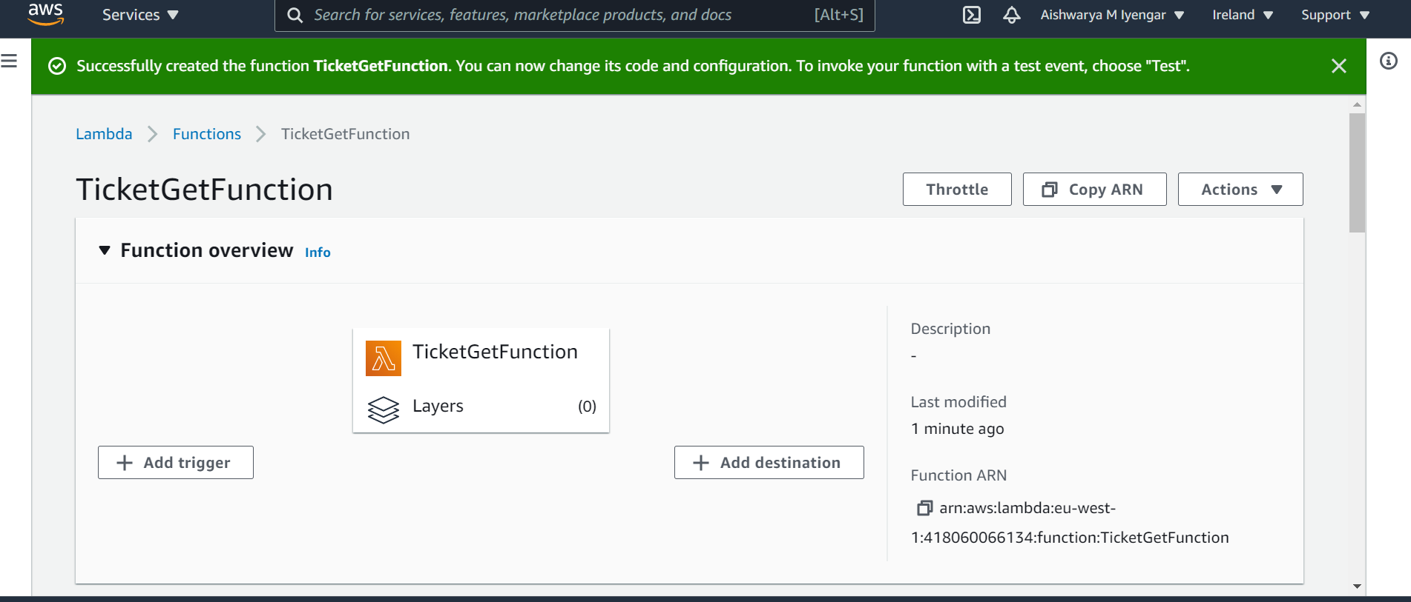

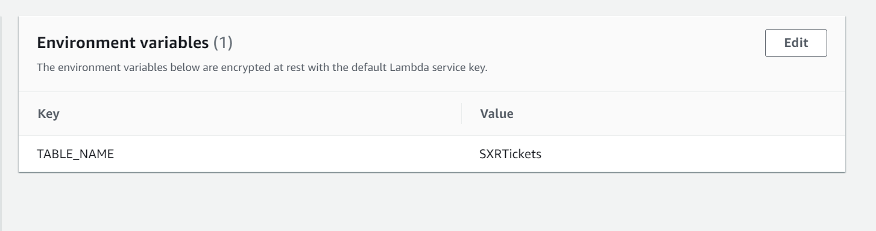

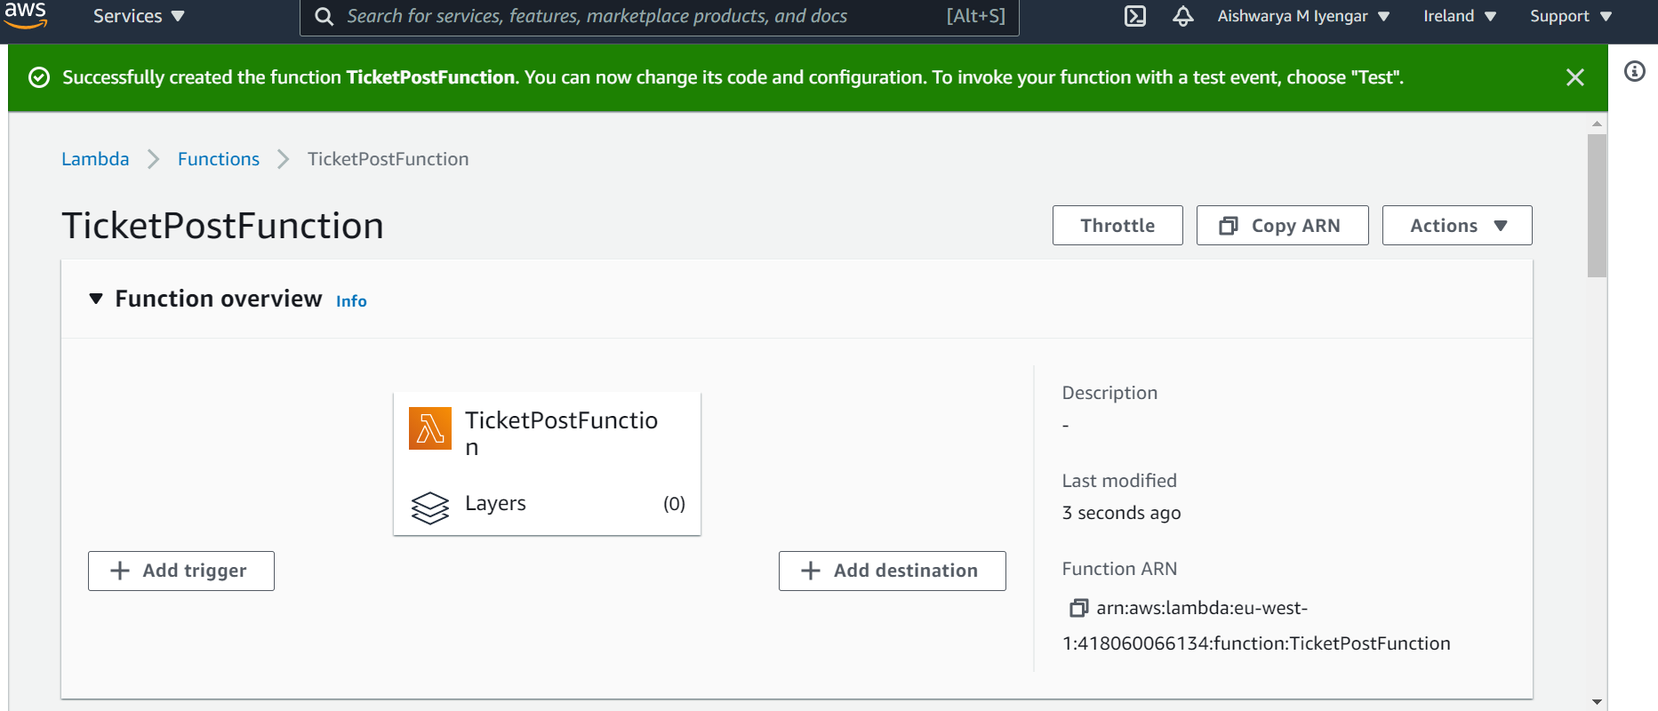

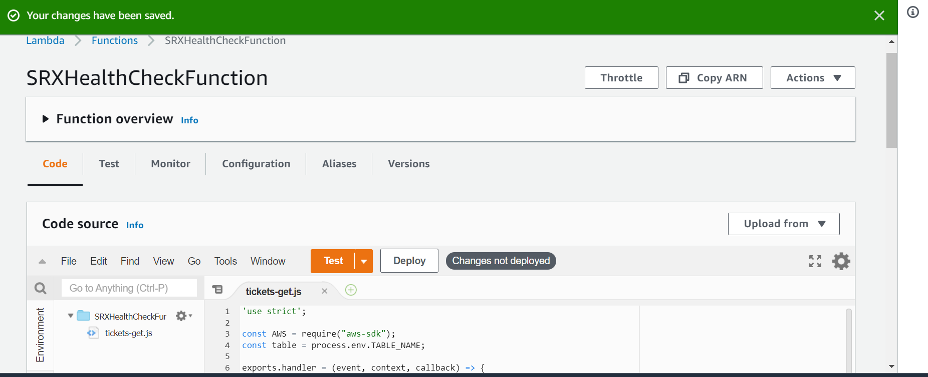

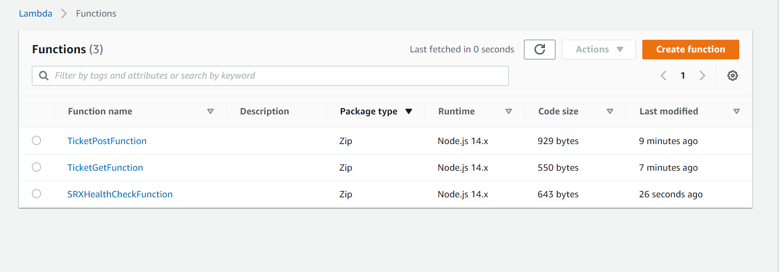

**4. Create API Gateway Endpoint:**

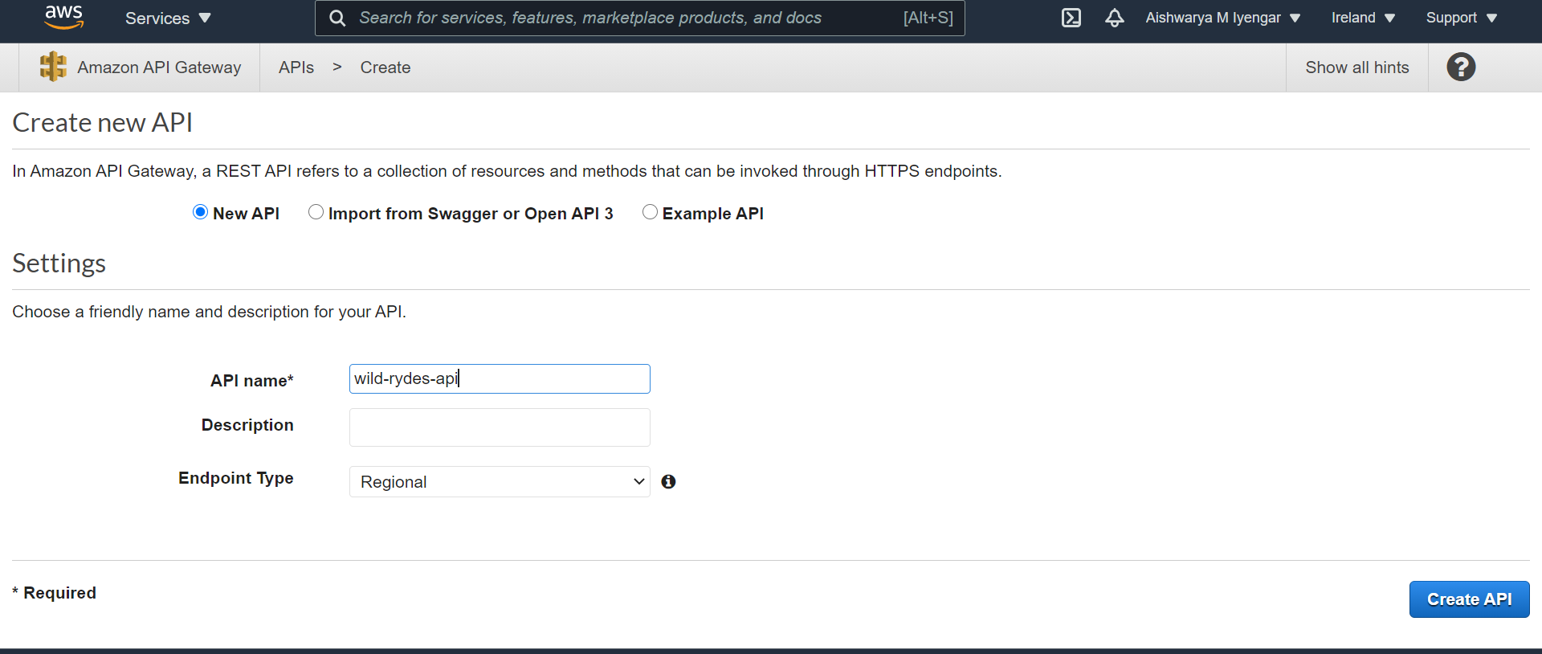

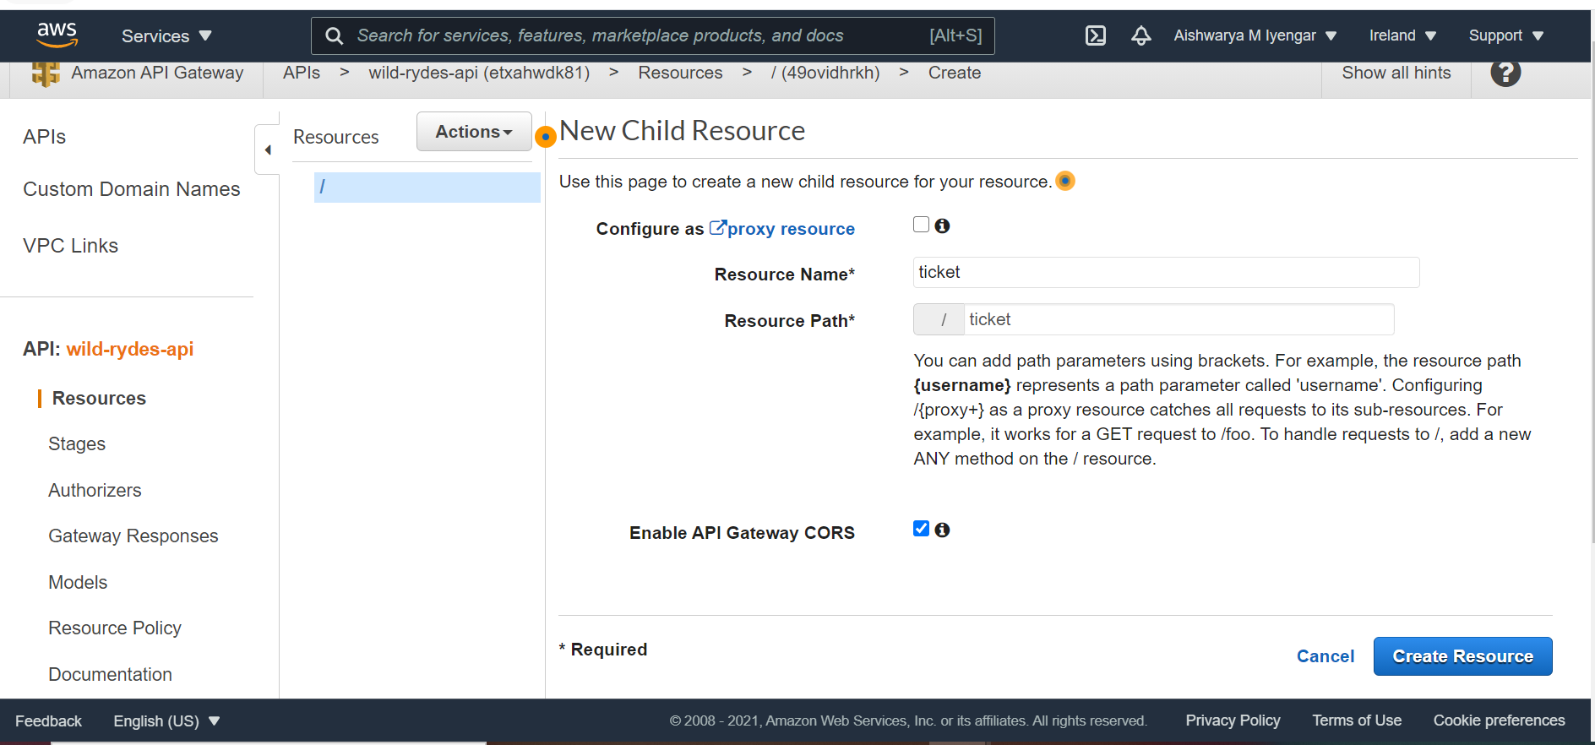

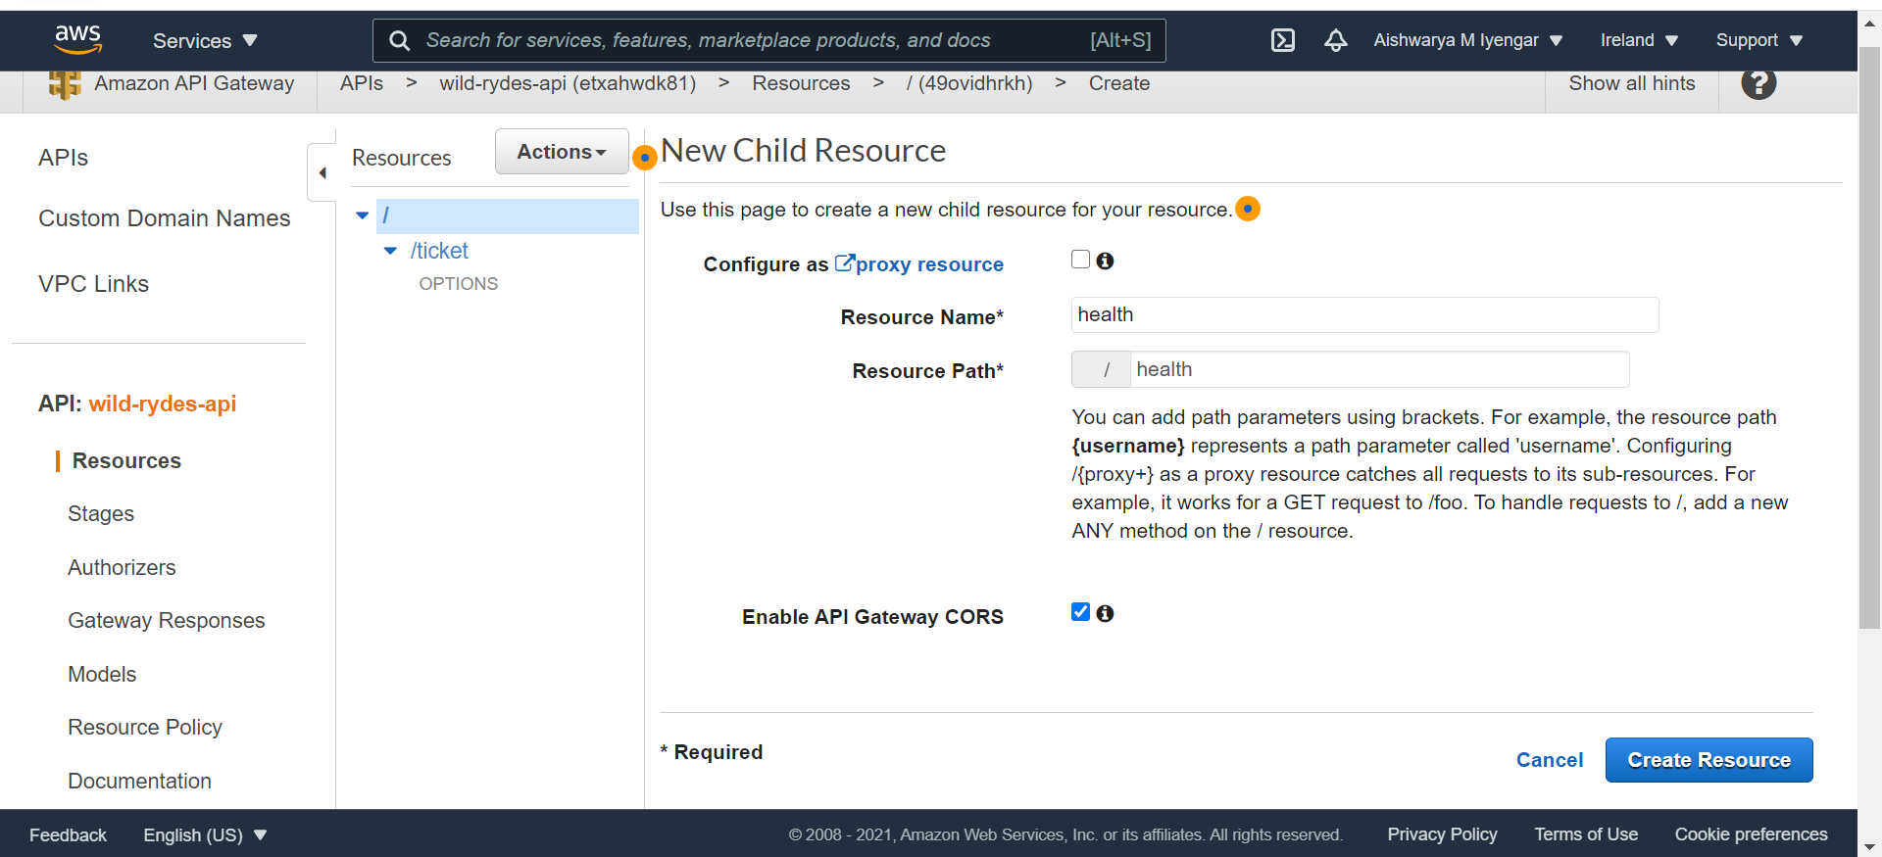

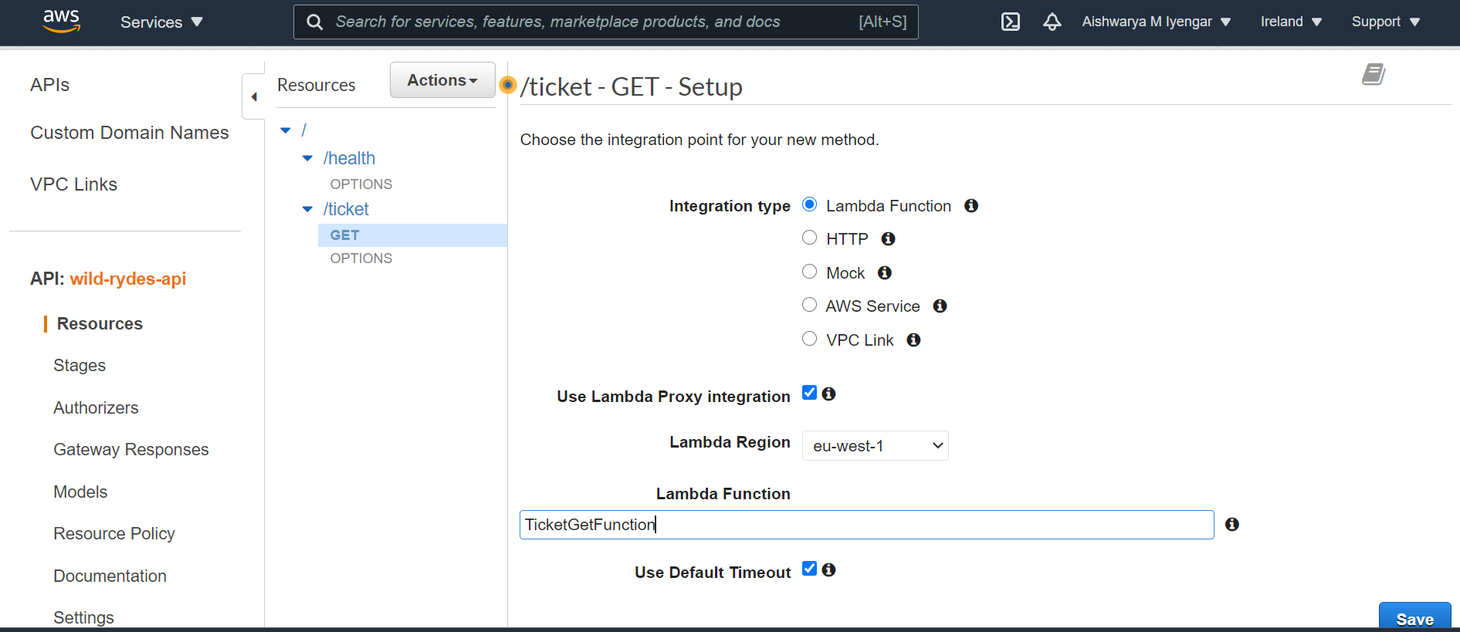

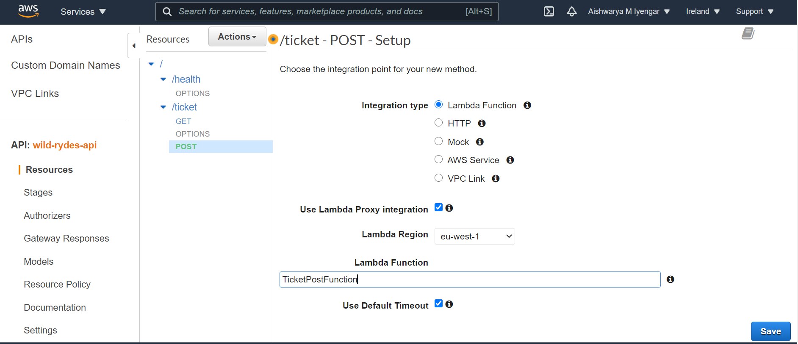

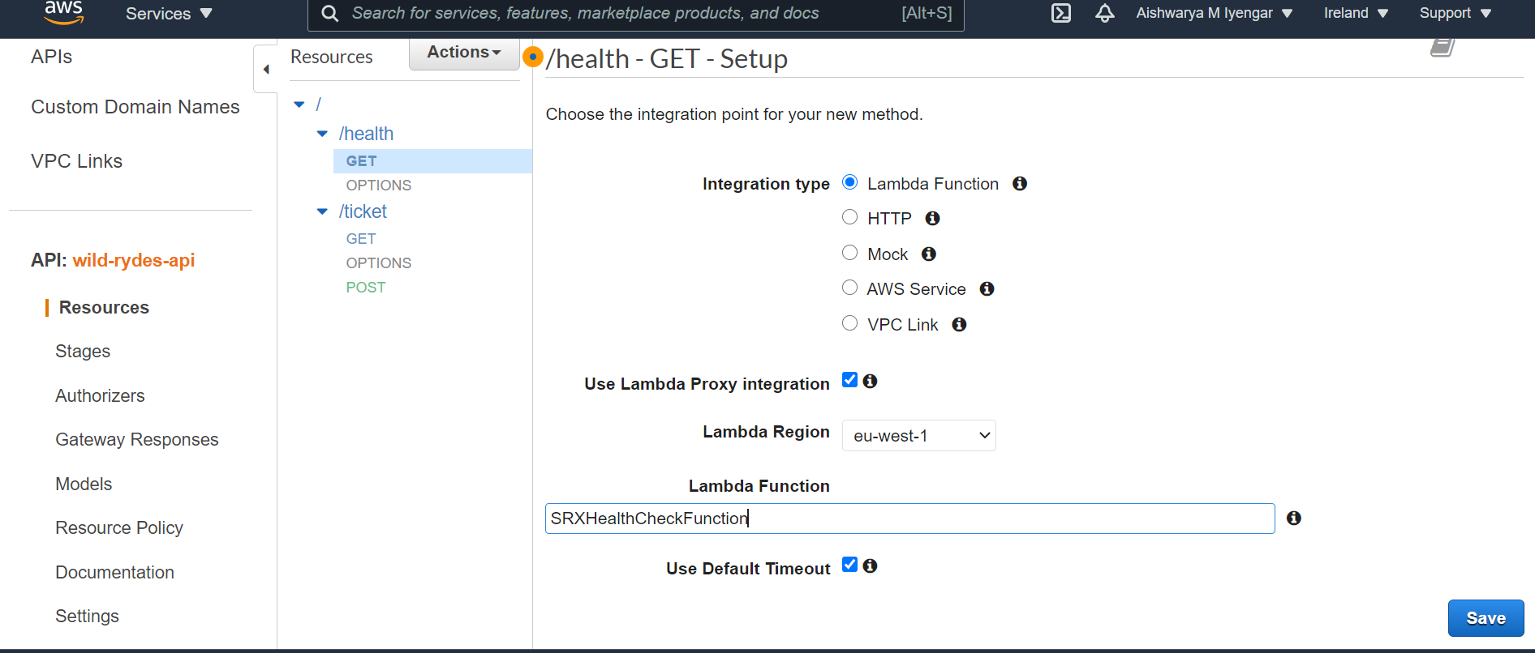

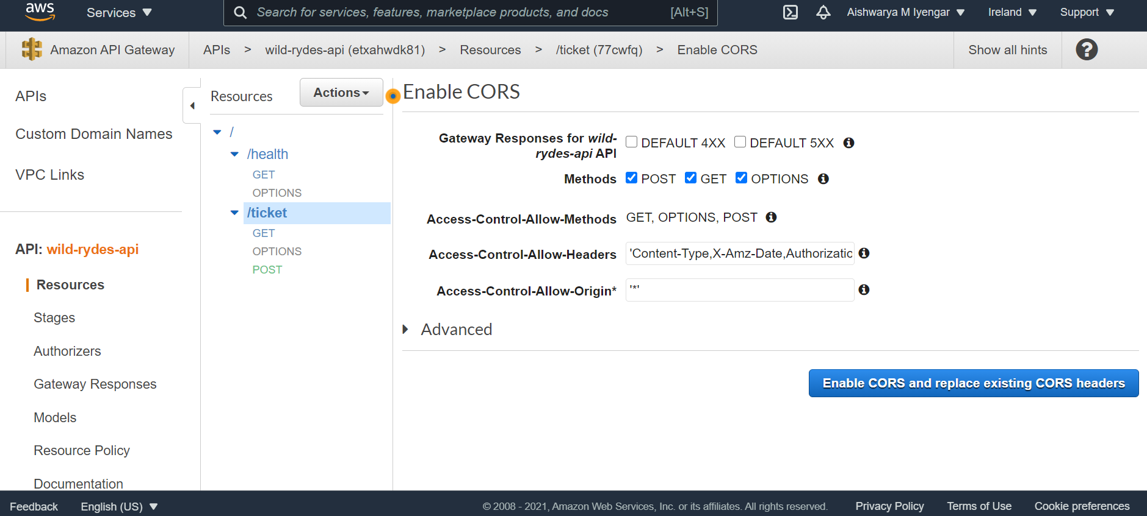

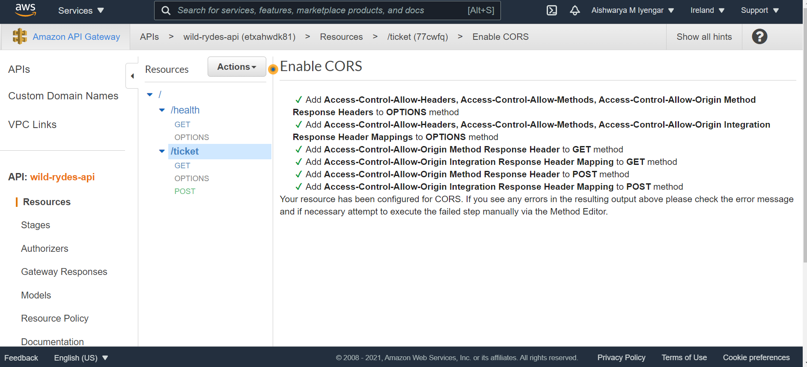

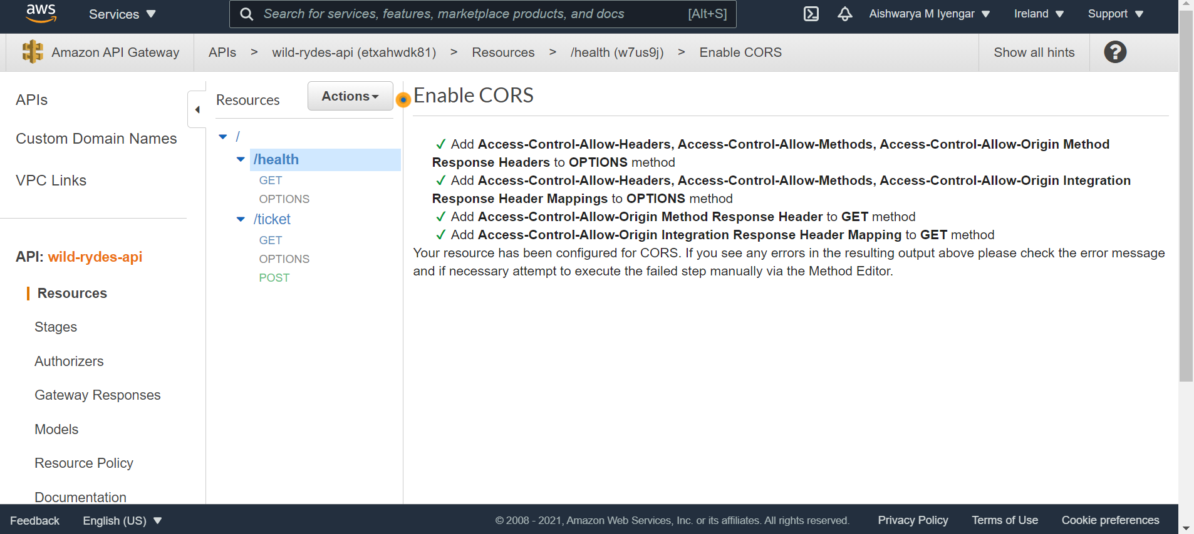

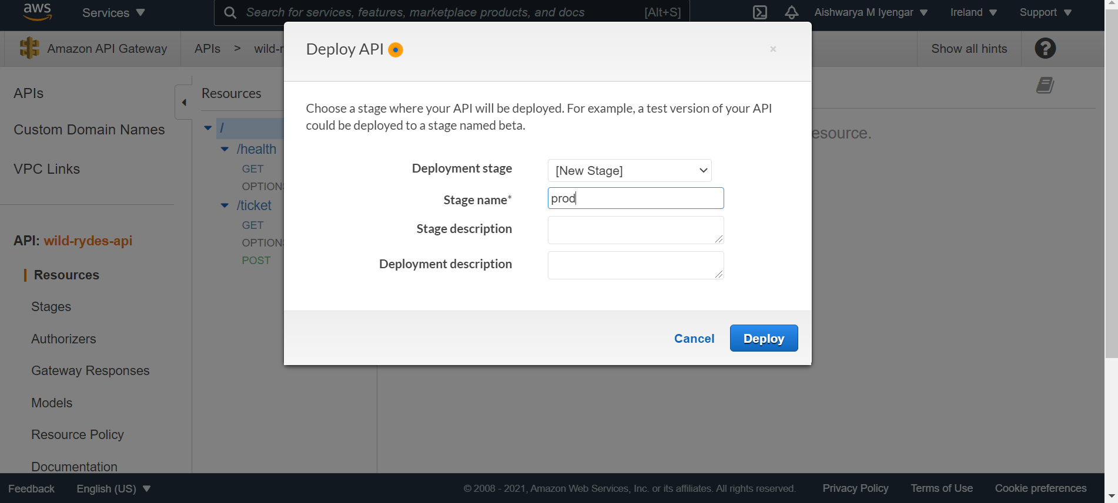

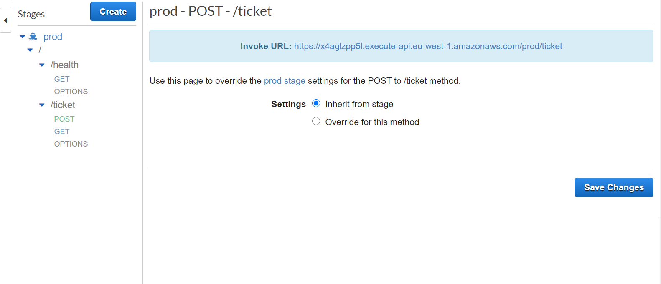

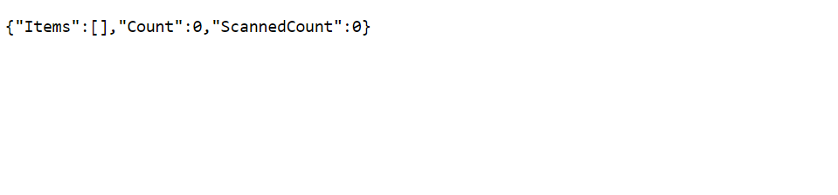

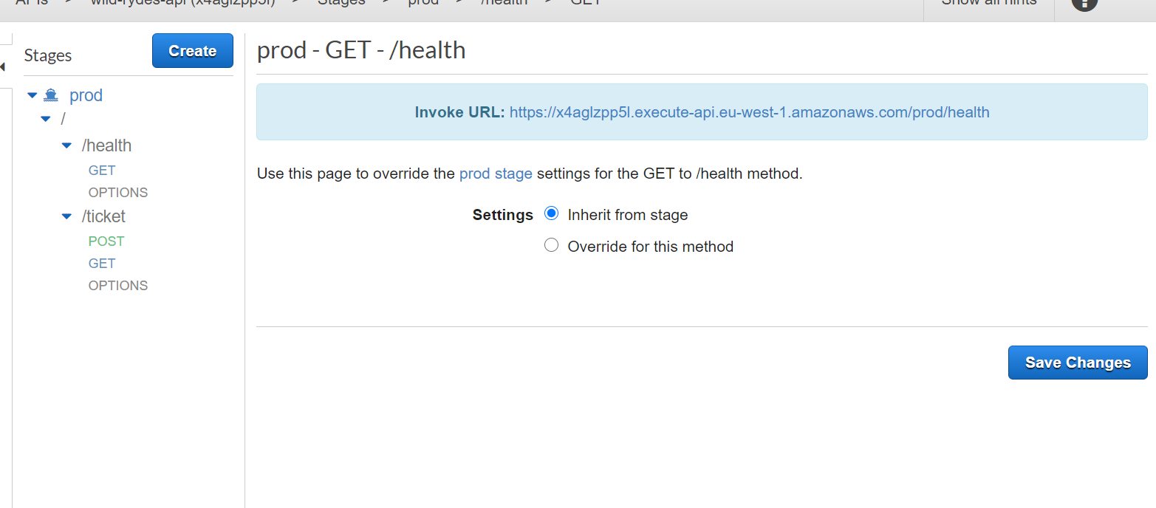

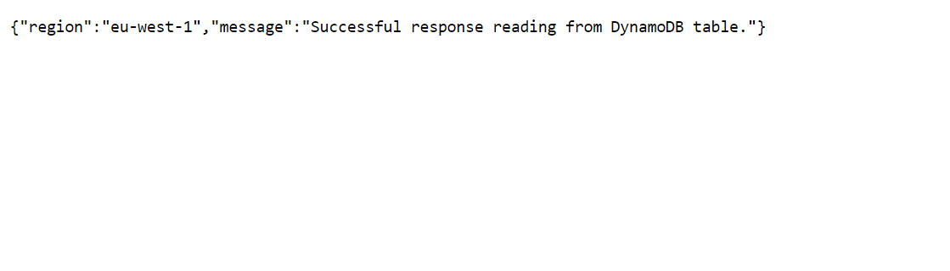

Till here the API are set up for the primary location. Now we will have to implement to the secondary location. Below are the SS for the same.

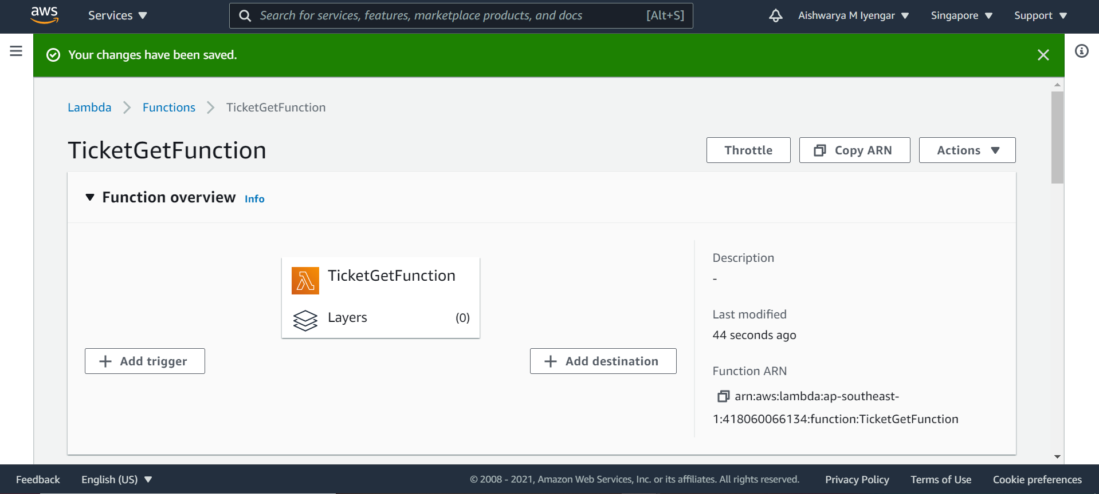

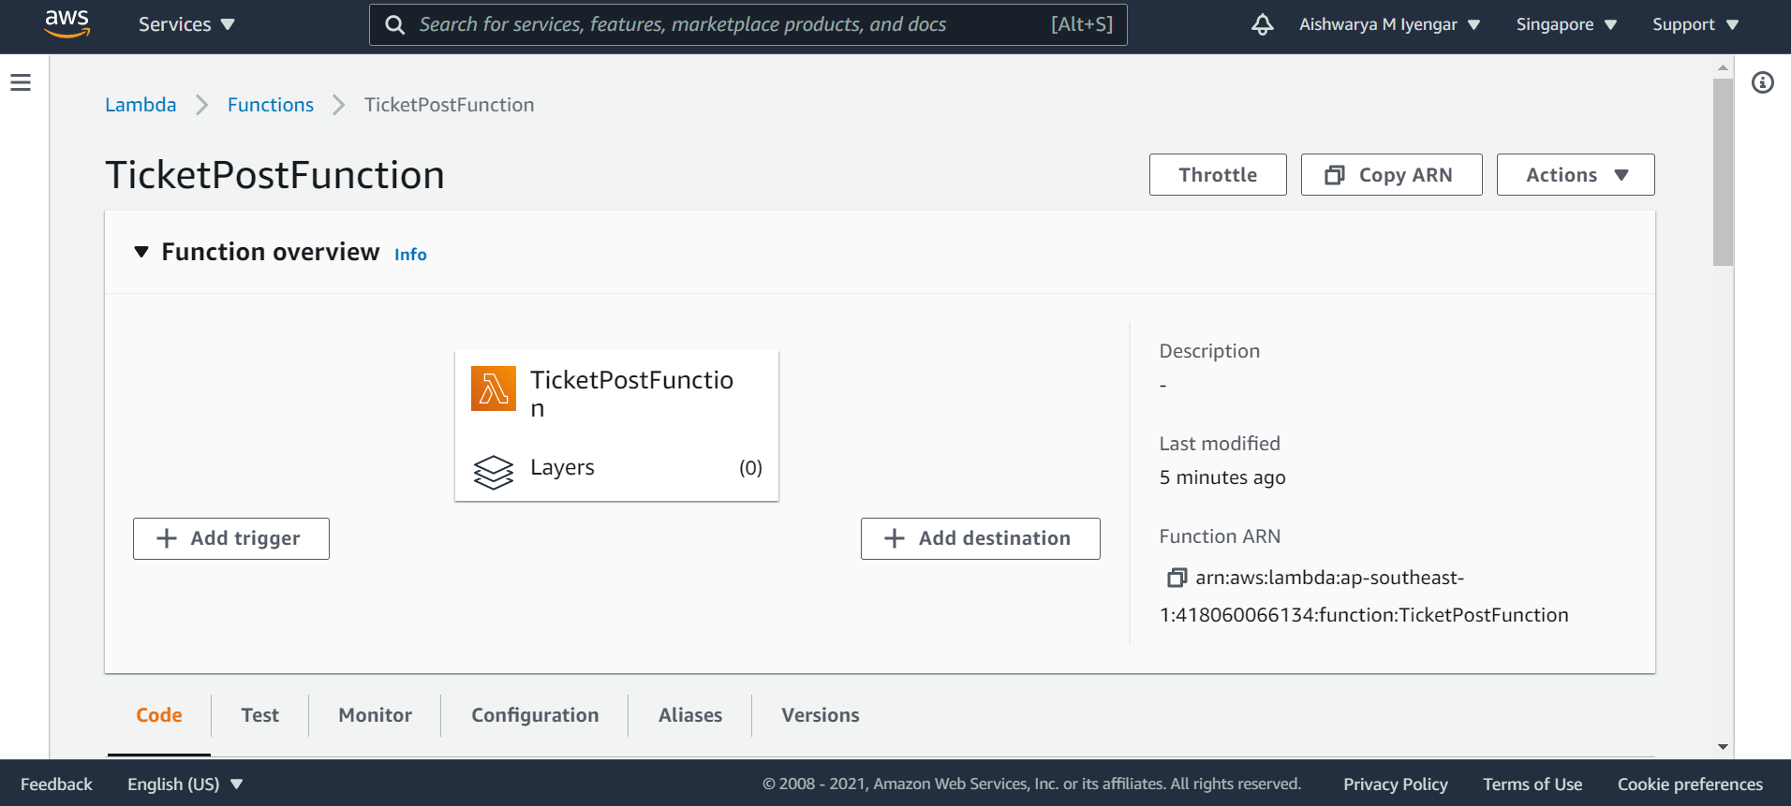

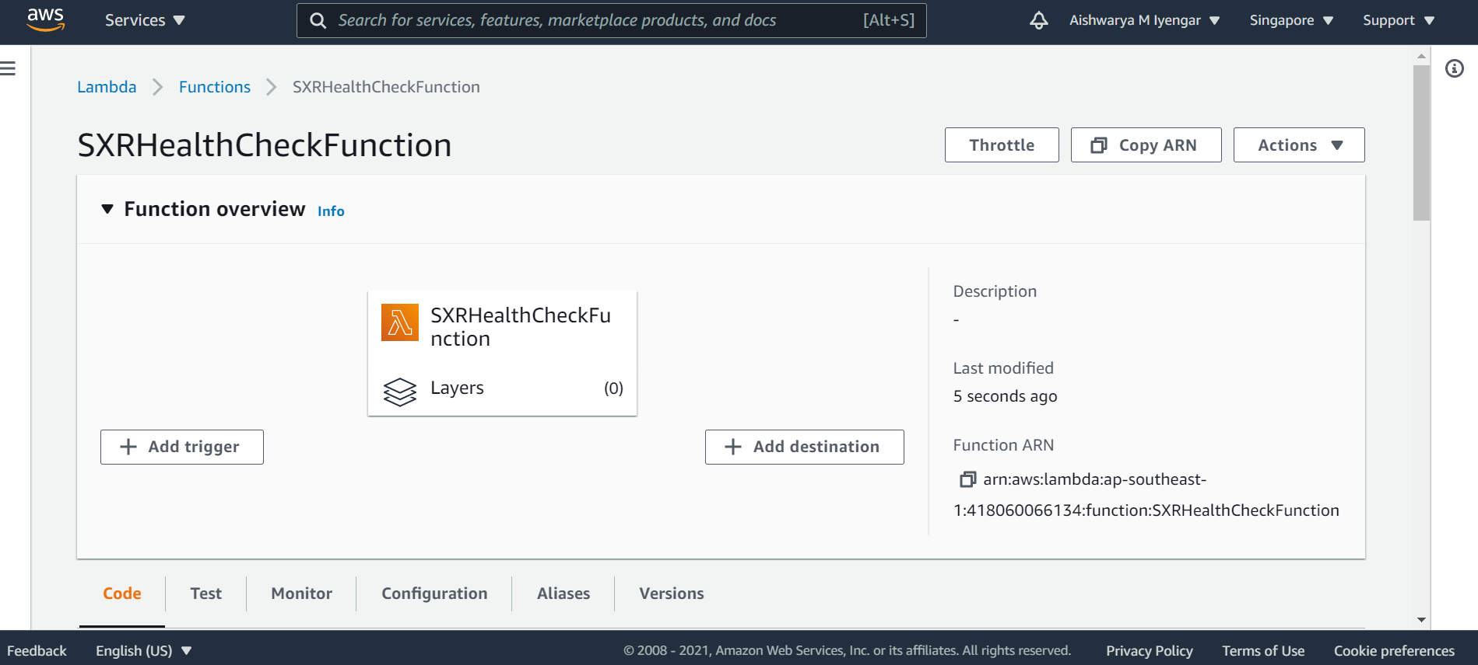

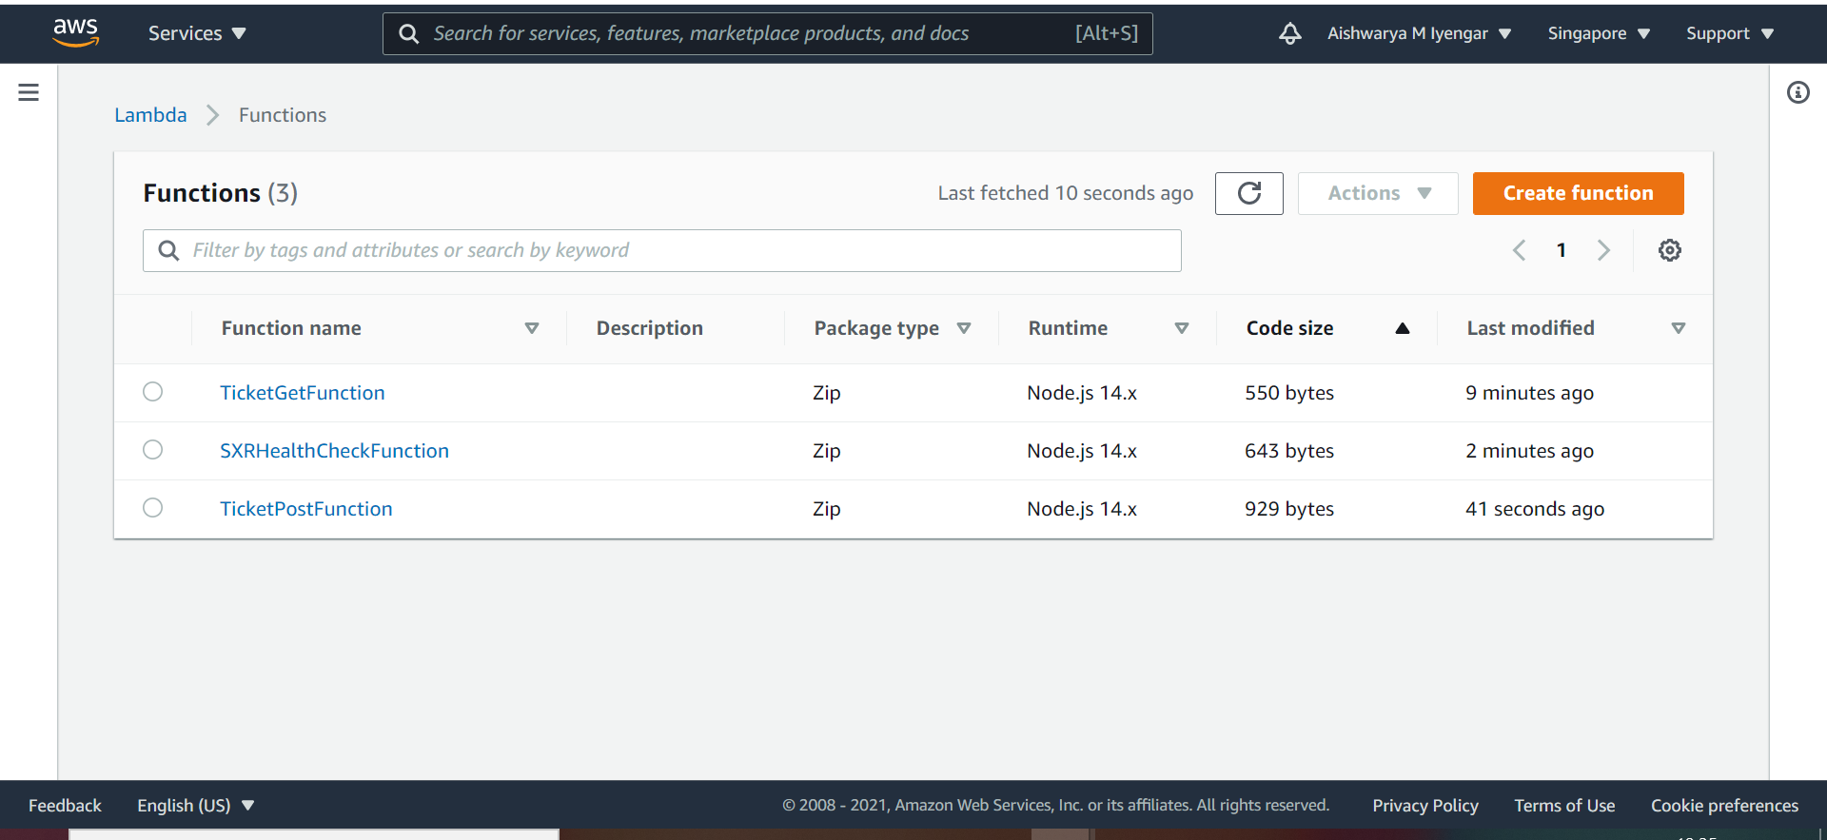

Now the API should be done in the secondary region too. The SS below shows the same.

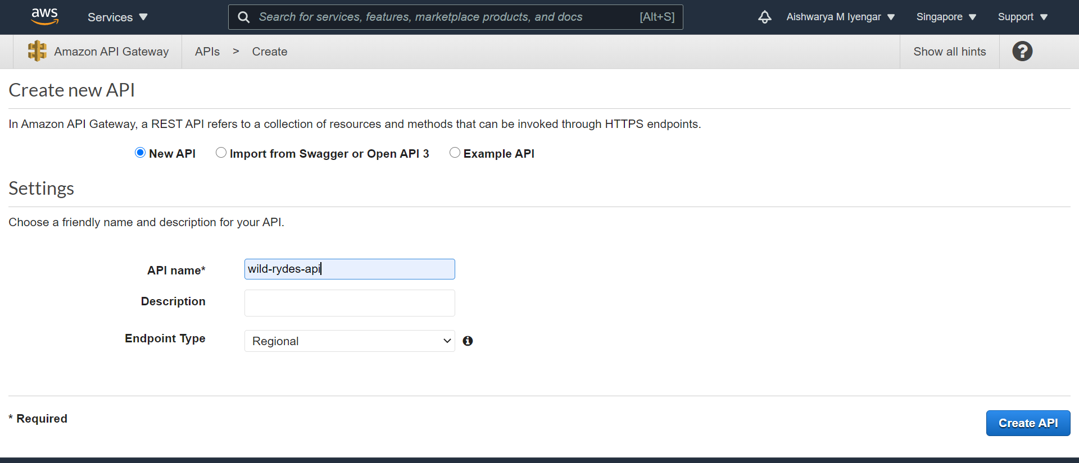

After the API is created, we created the methods inside each resources just like we did for the primary region.

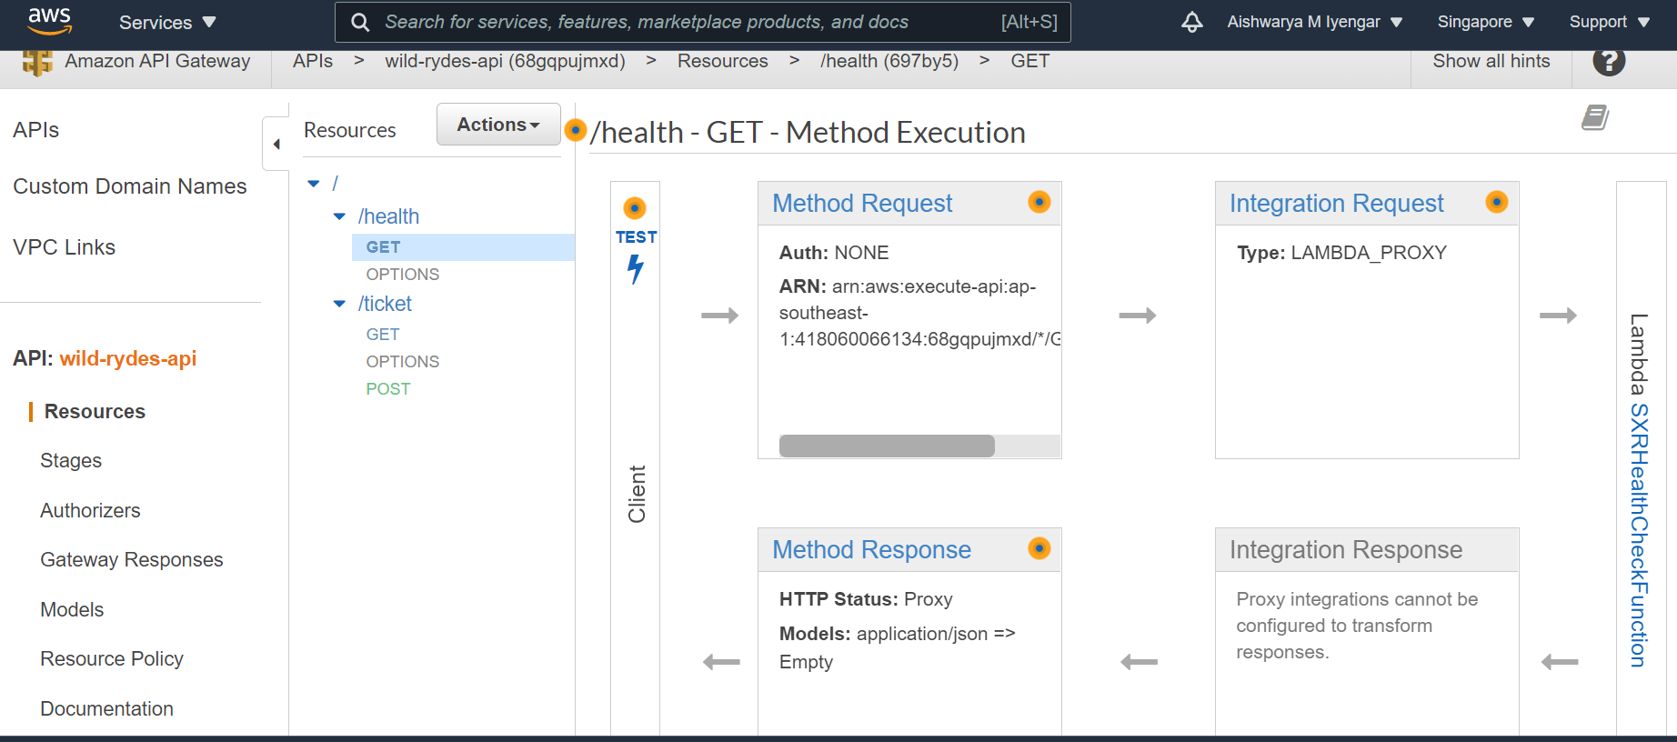

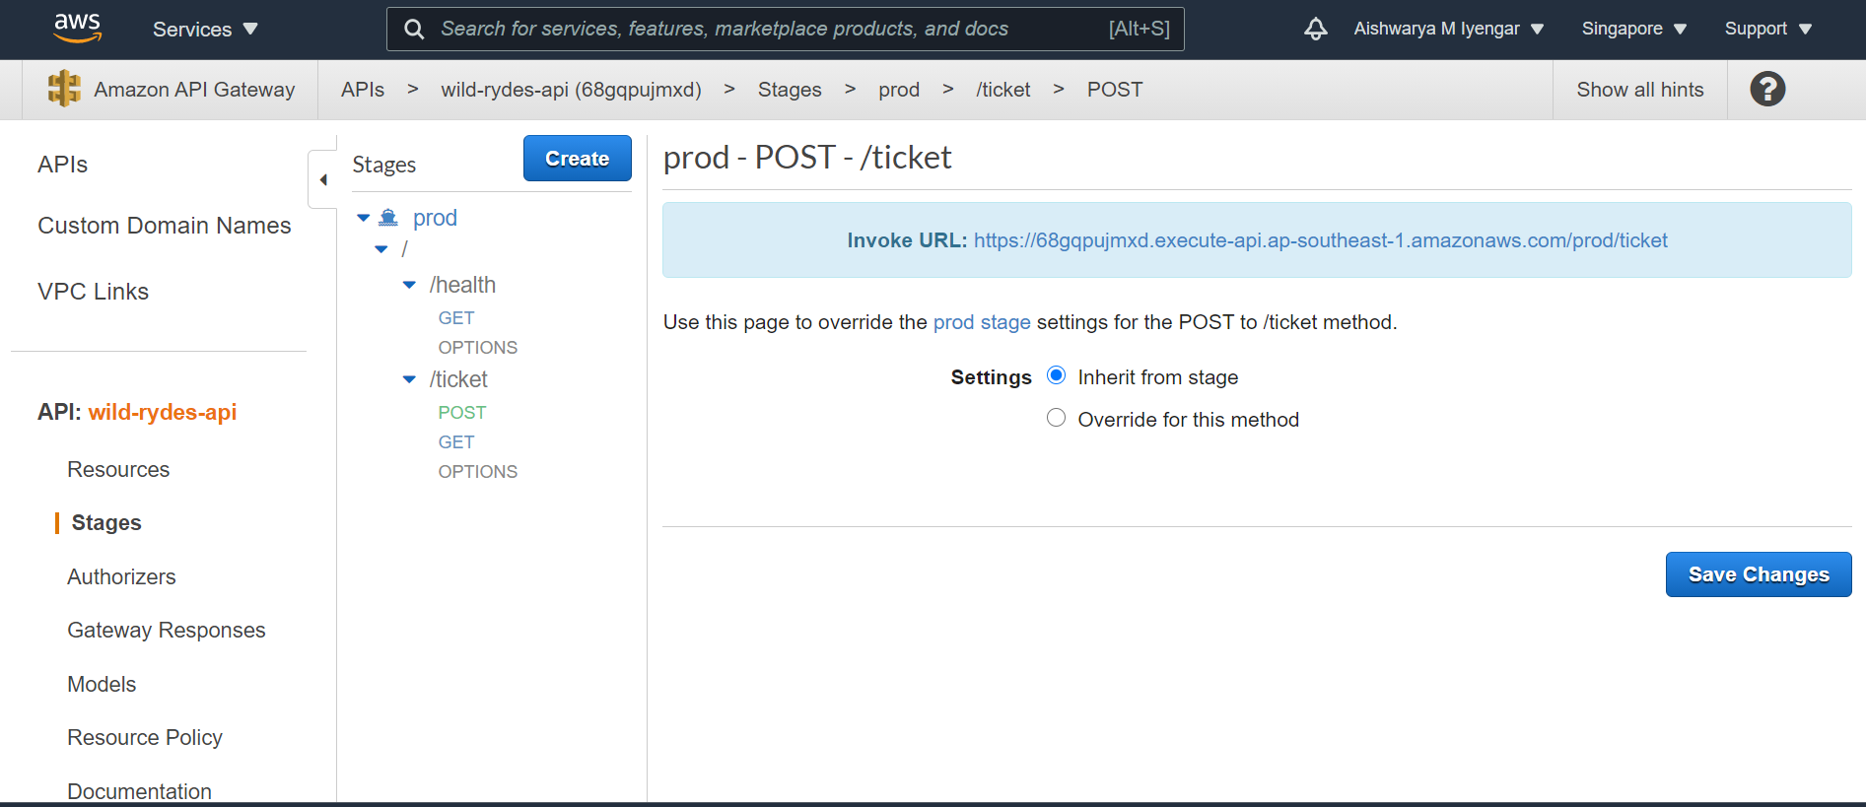

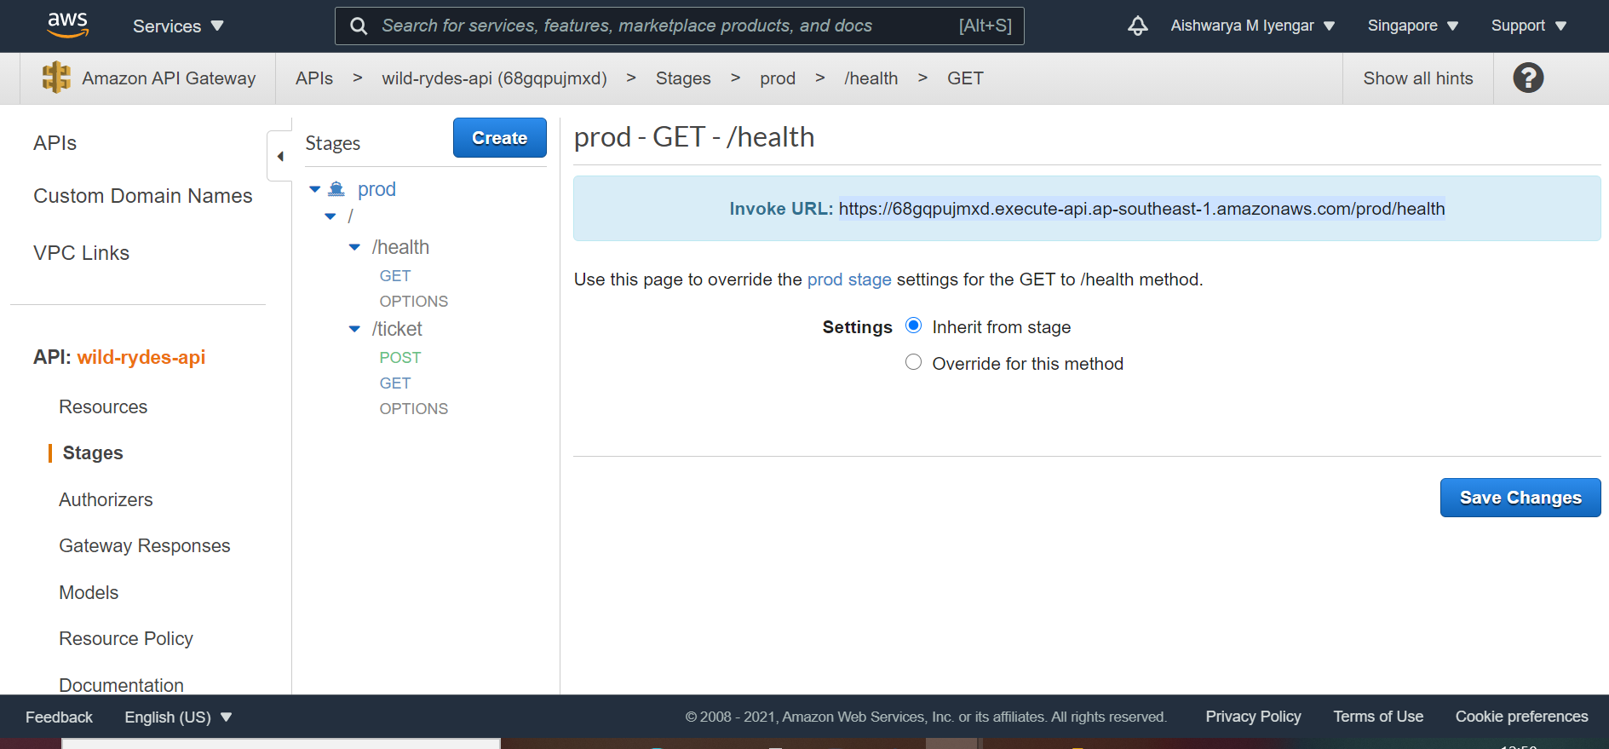

**3. Build an UI**

## 1. Create the AWS Cognito Identity Pool, S3 bucket and Cloud front distribution

Building of an UI is done in order to expose the functionality to the users.

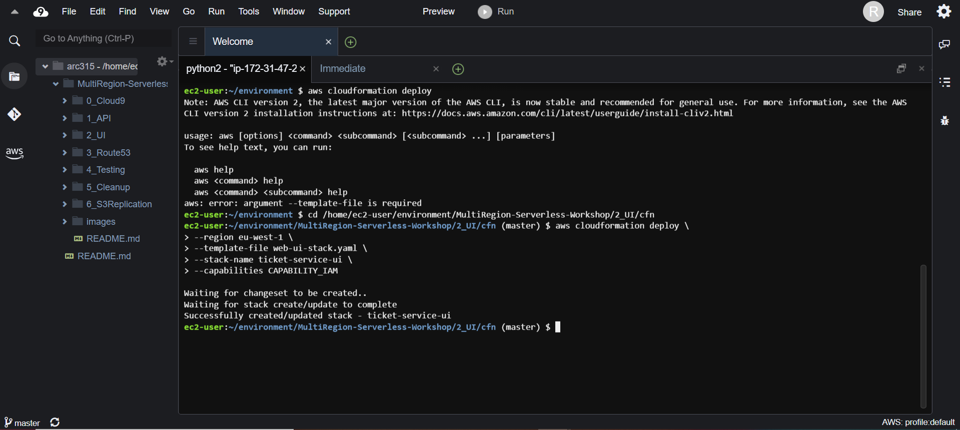

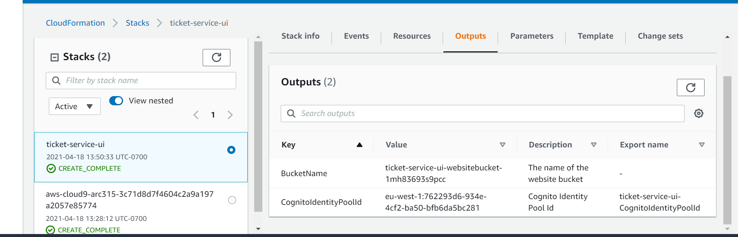

|  |  |
| --- | --- |
| Key | Value |
| BucketName | ticket-service-ui-websitebucket-1mh83693s9pcc |
| CognitoIdentityPoolId | eu-west-1:762293d6-934e-4cf2-ba50-bfb6da5bc281 |

Now we do the cloud front distribution for the S3 bucket we created previously.

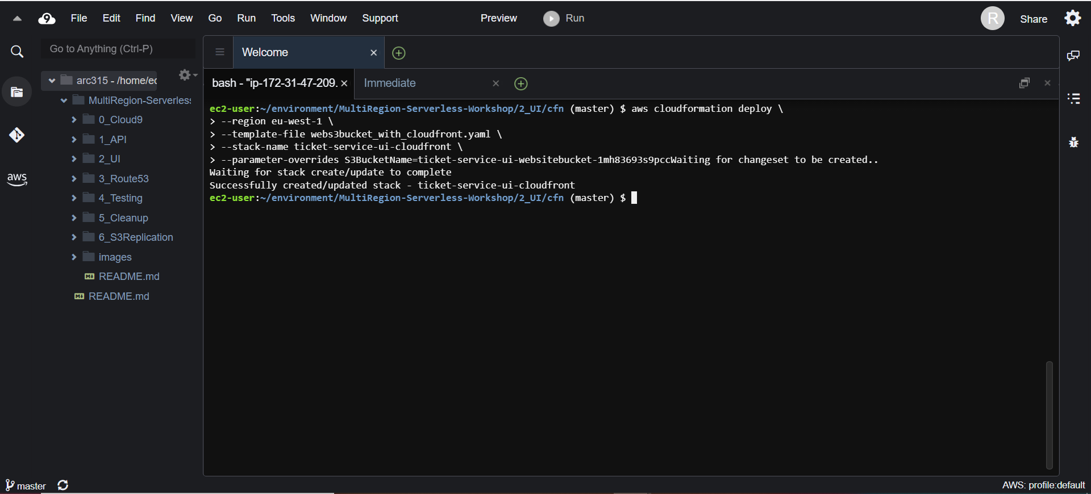

## **2. Configure Federated Identities with Cognito**

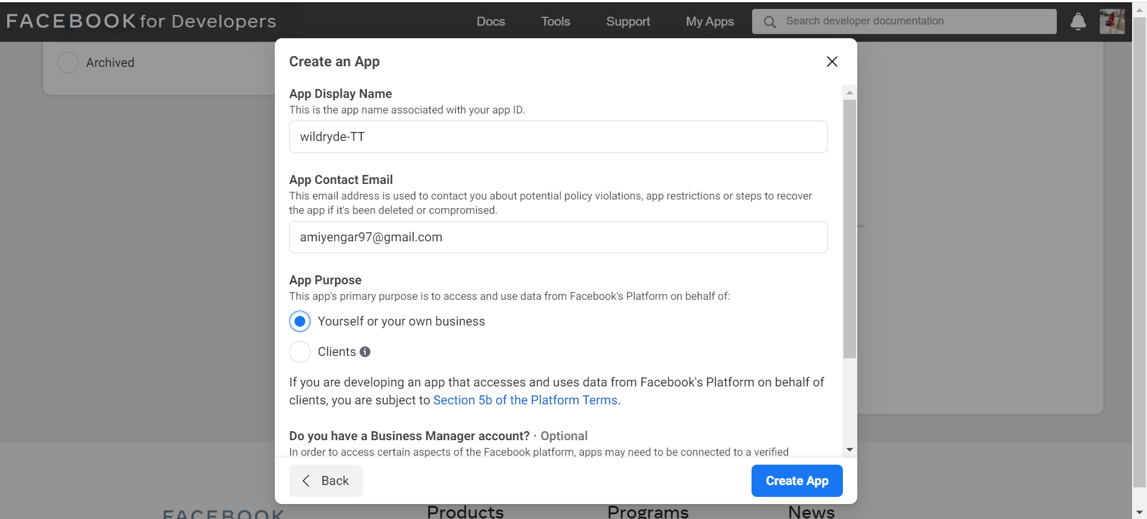

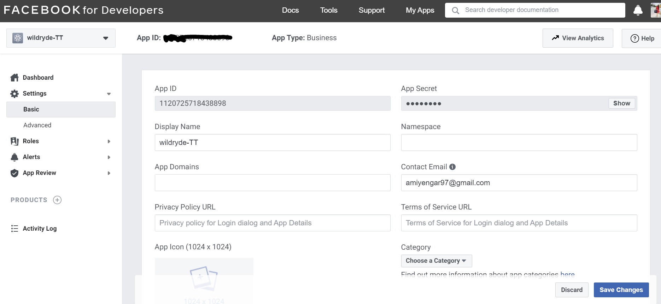

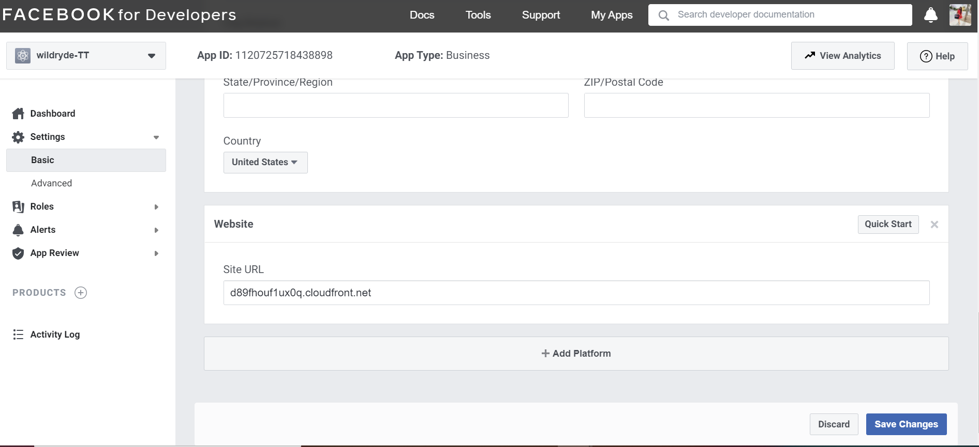

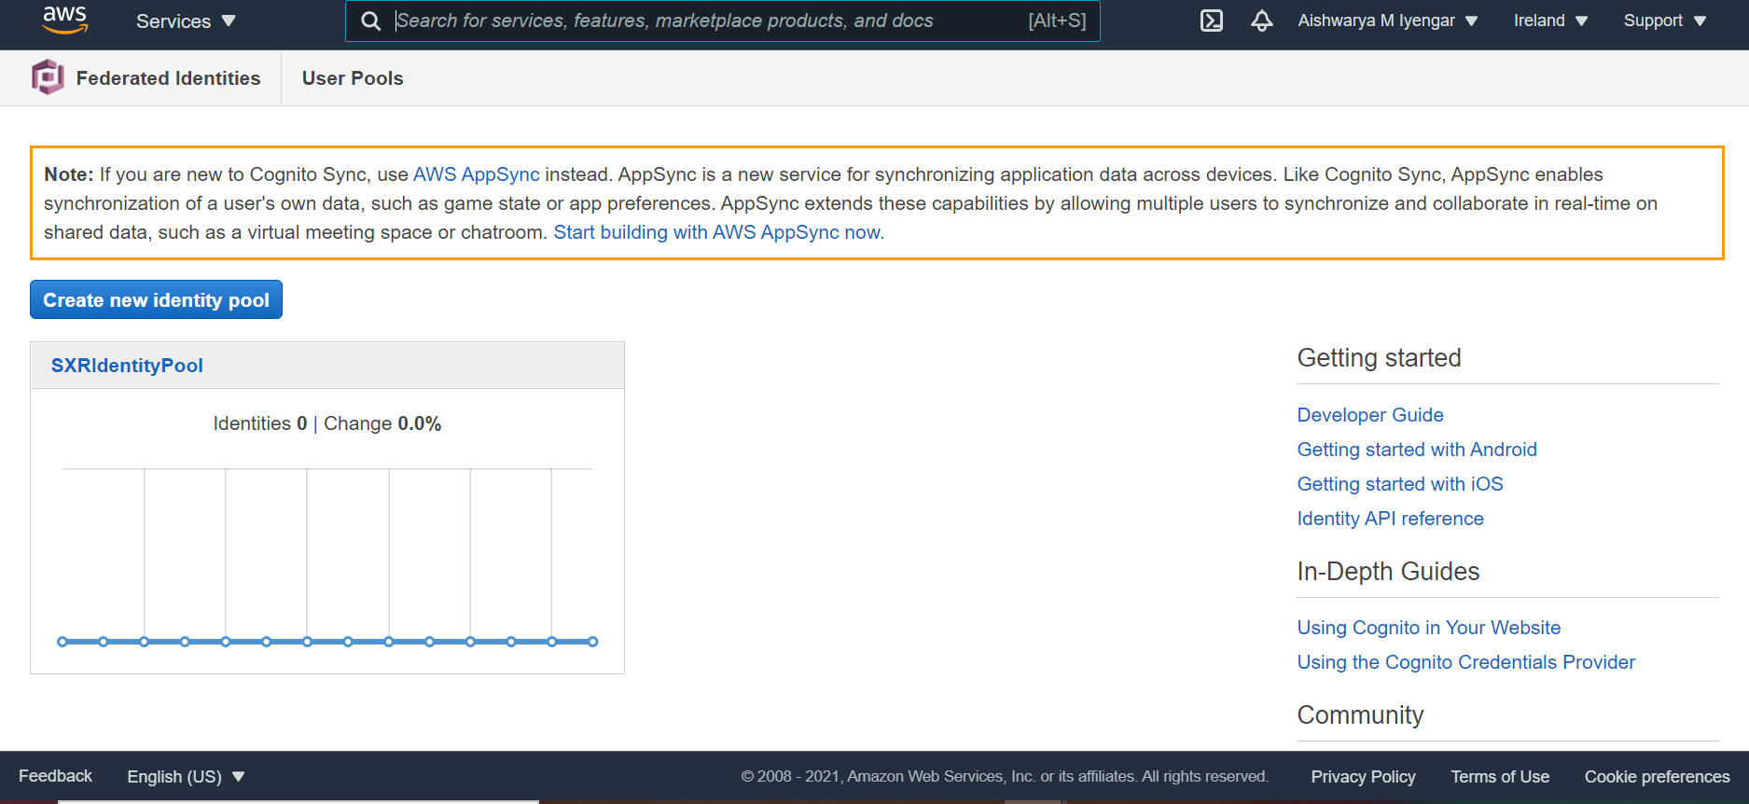

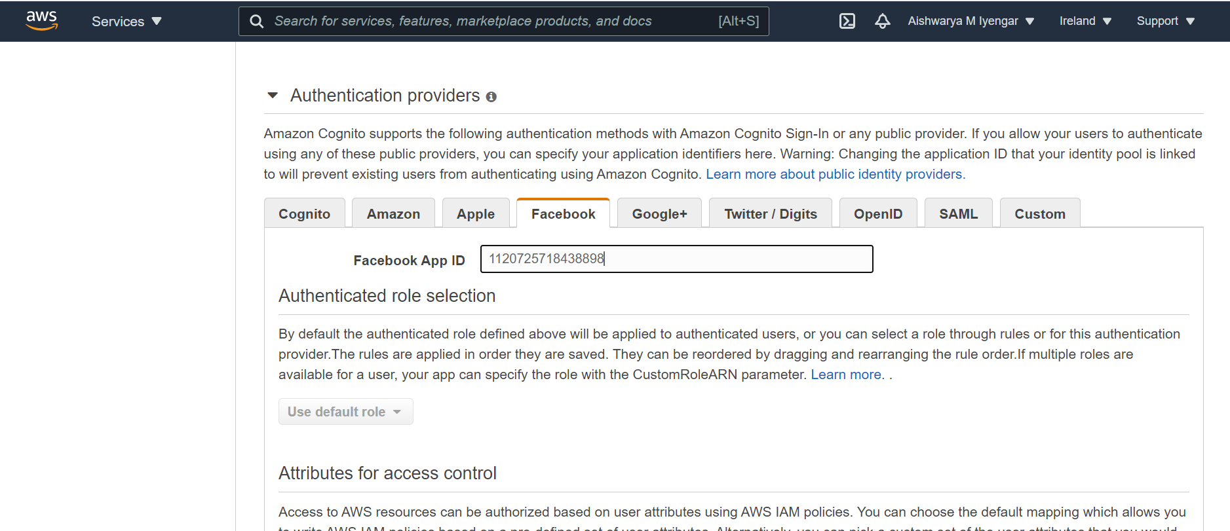

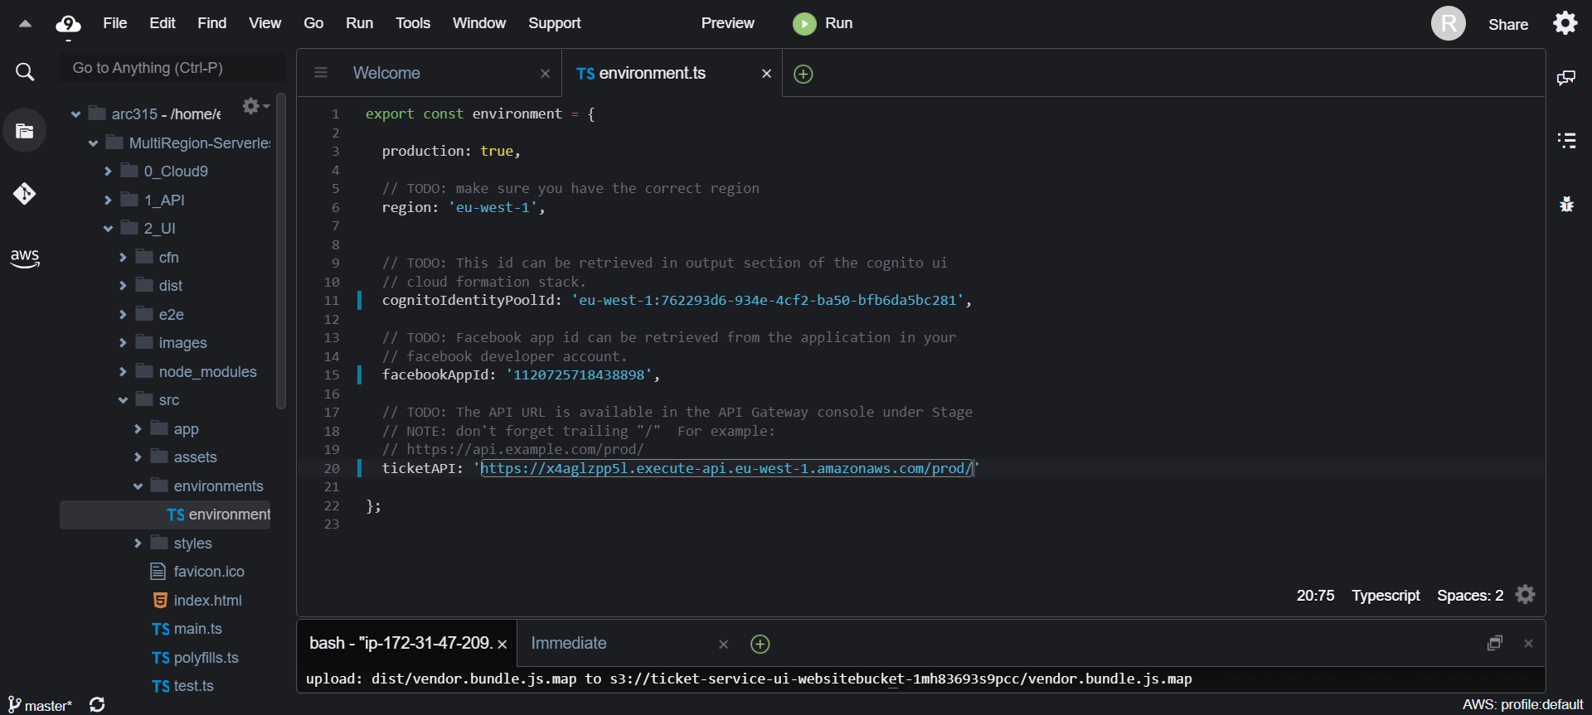

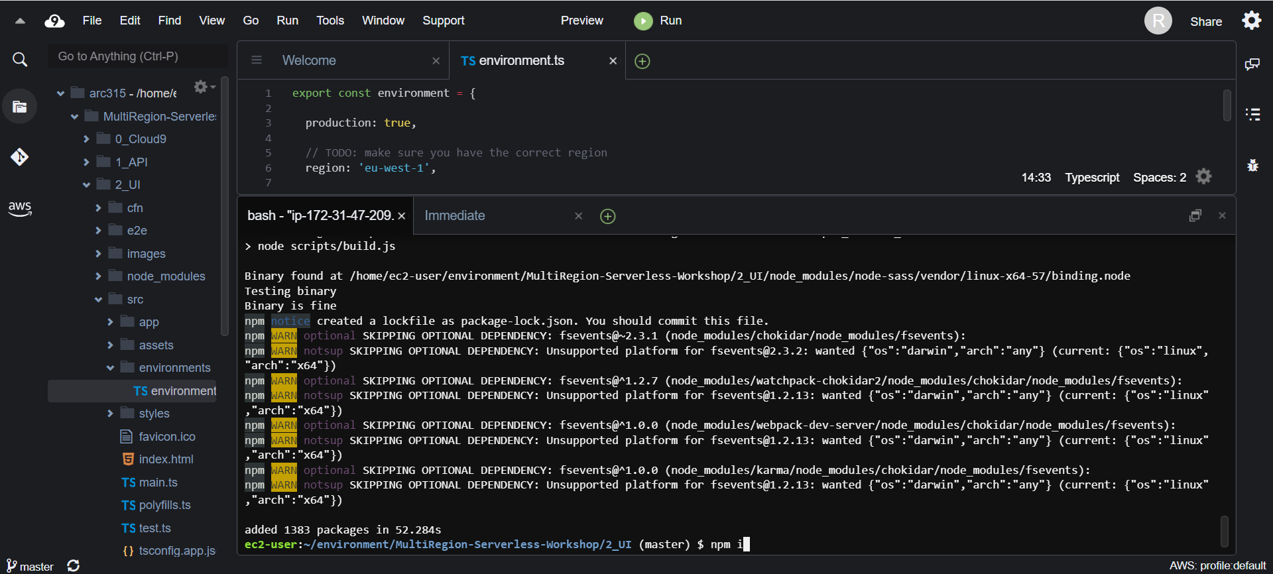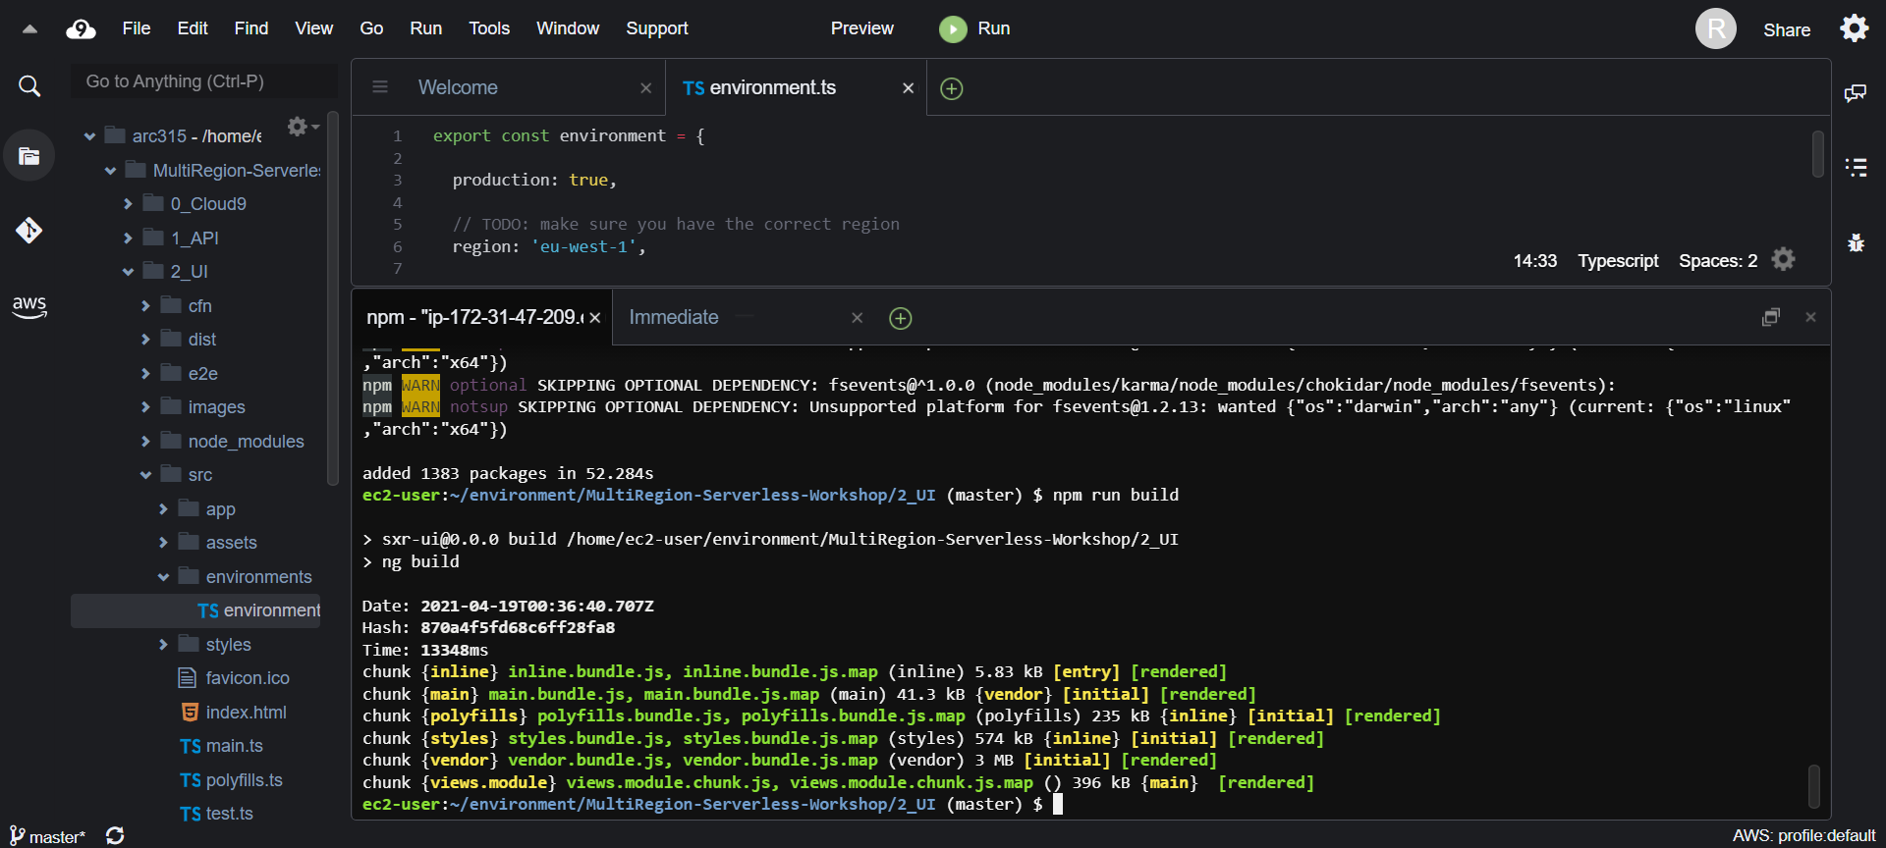 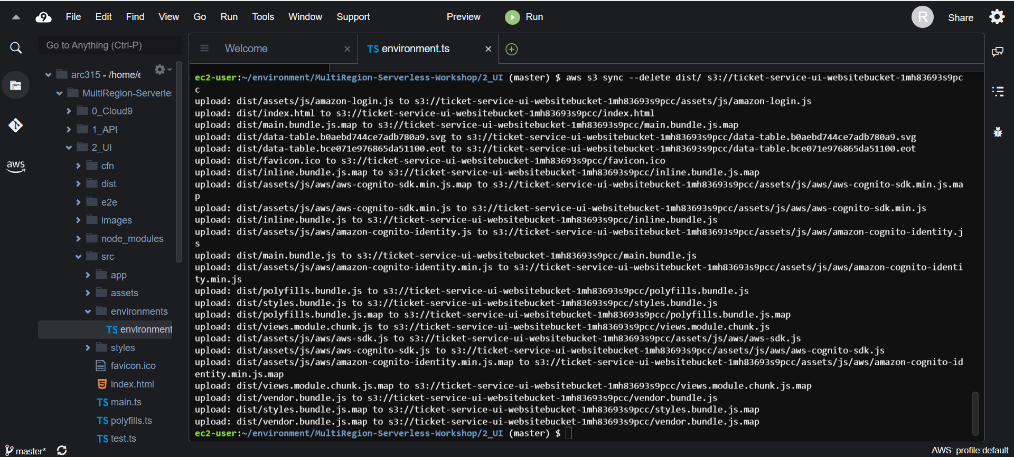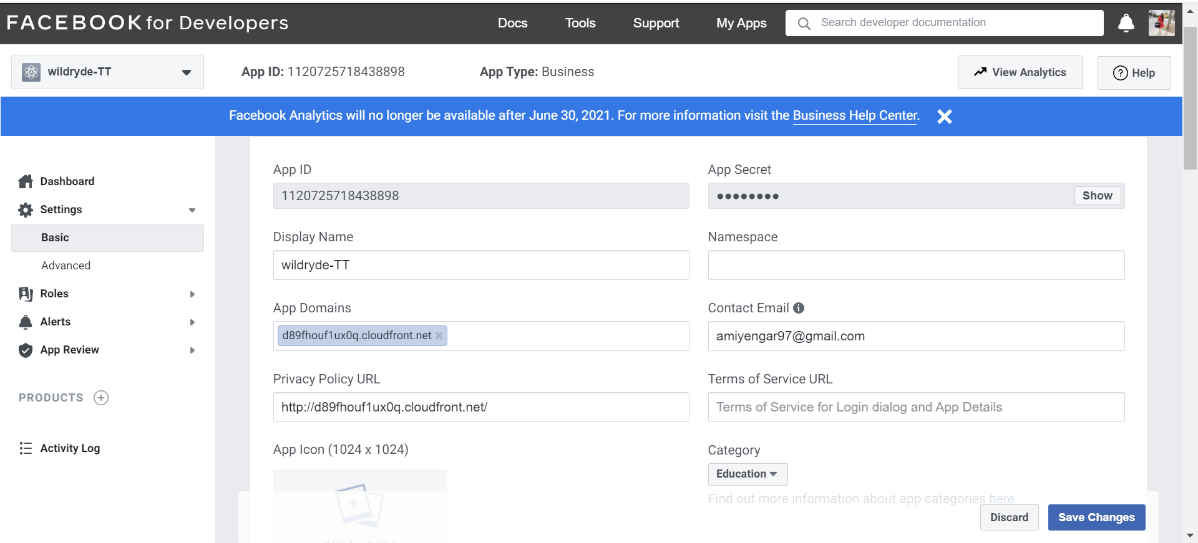

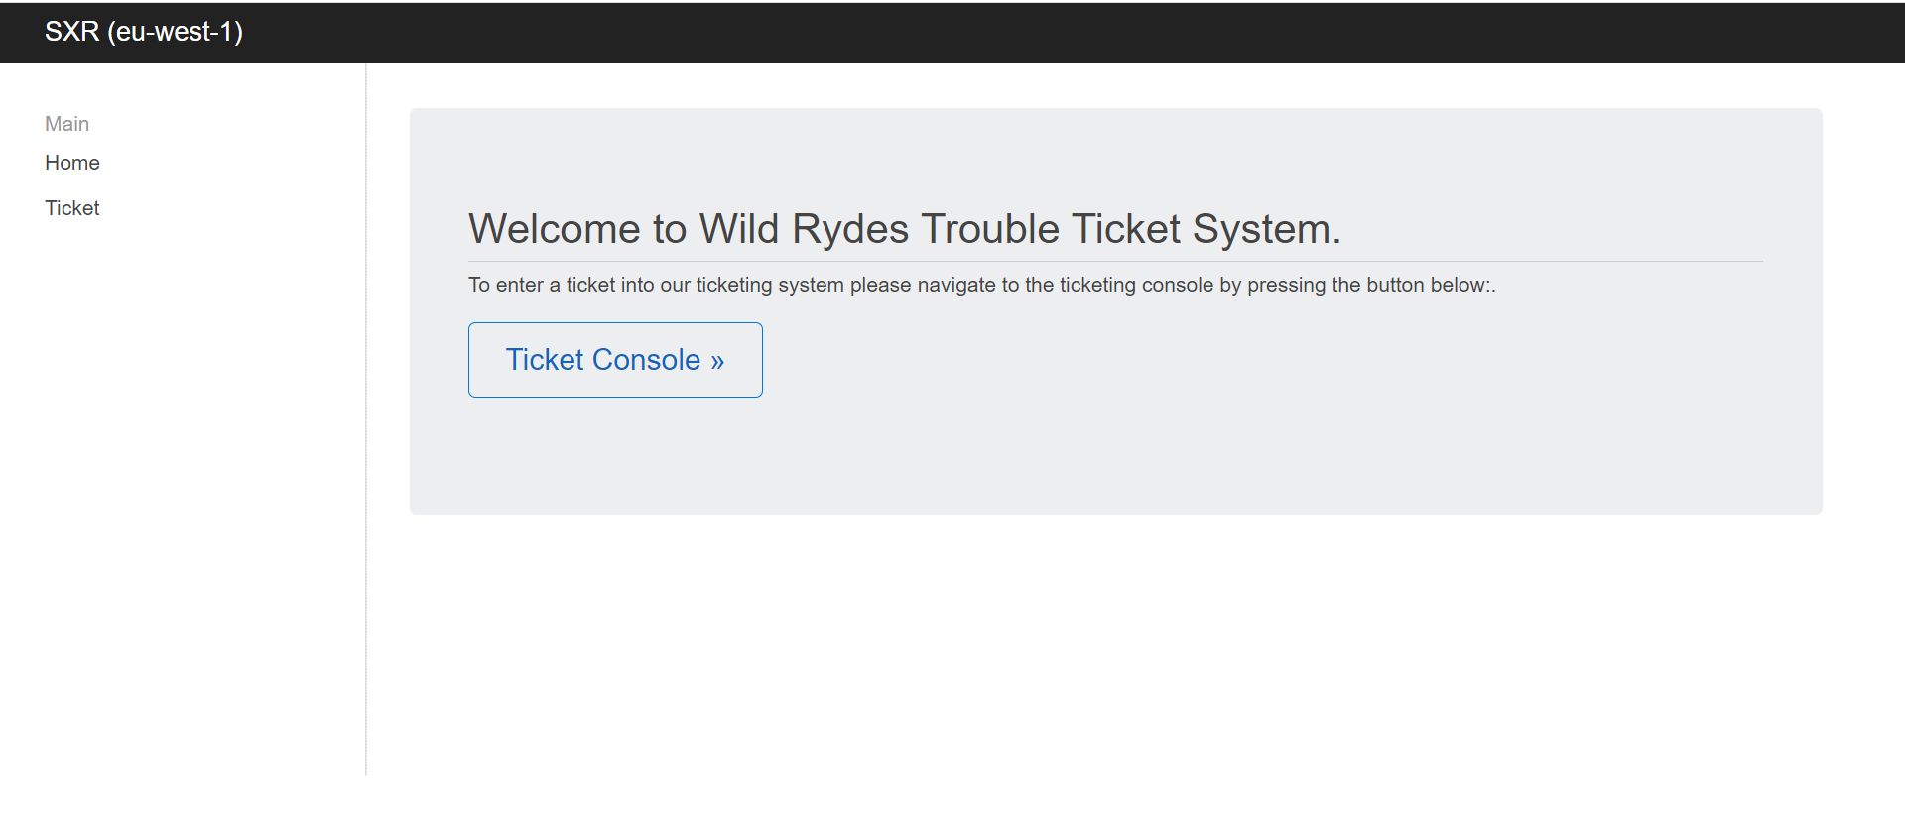

**4. Replicate to second region**

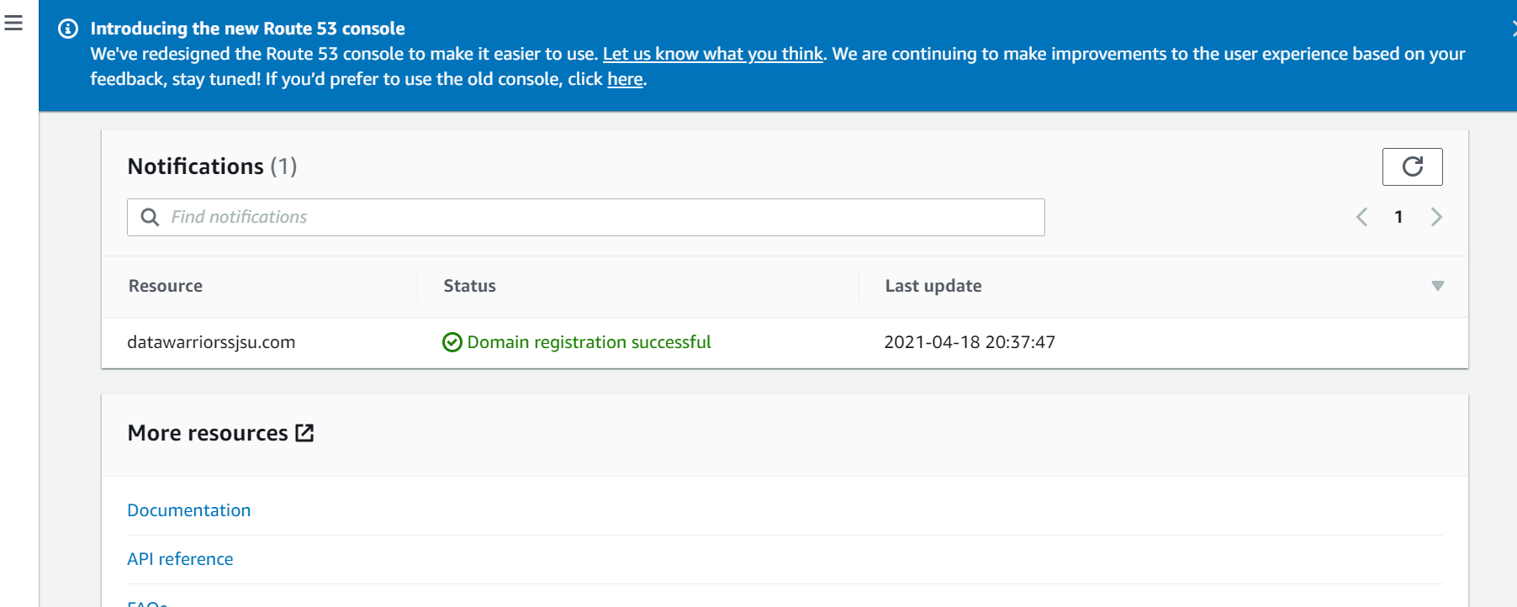

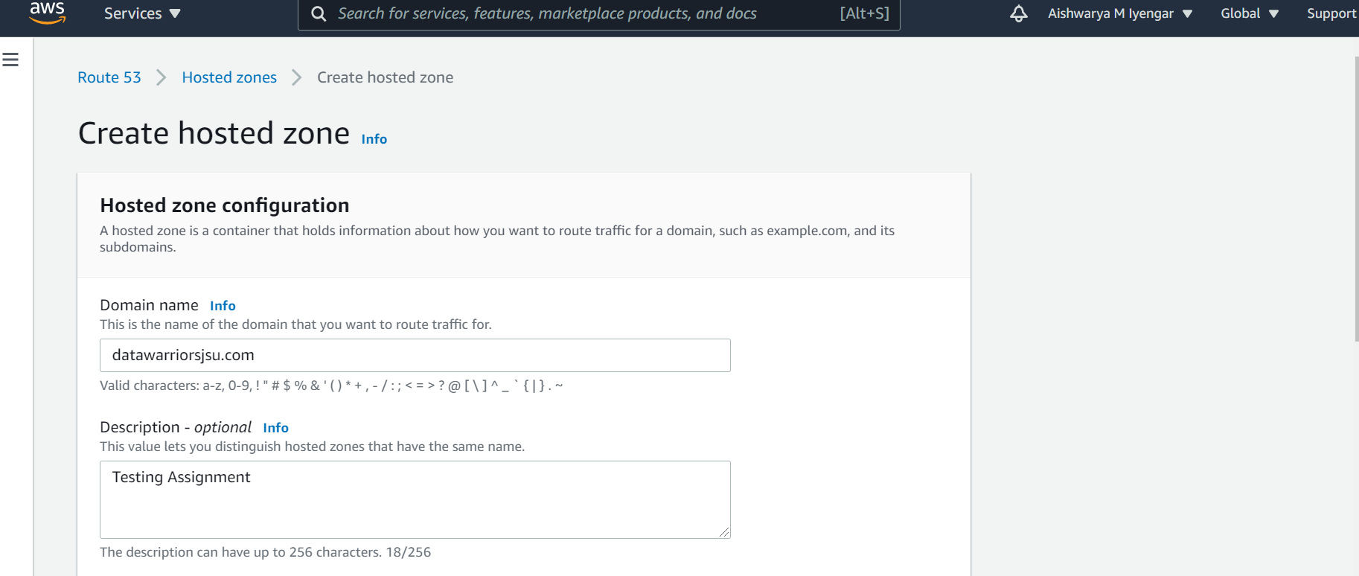

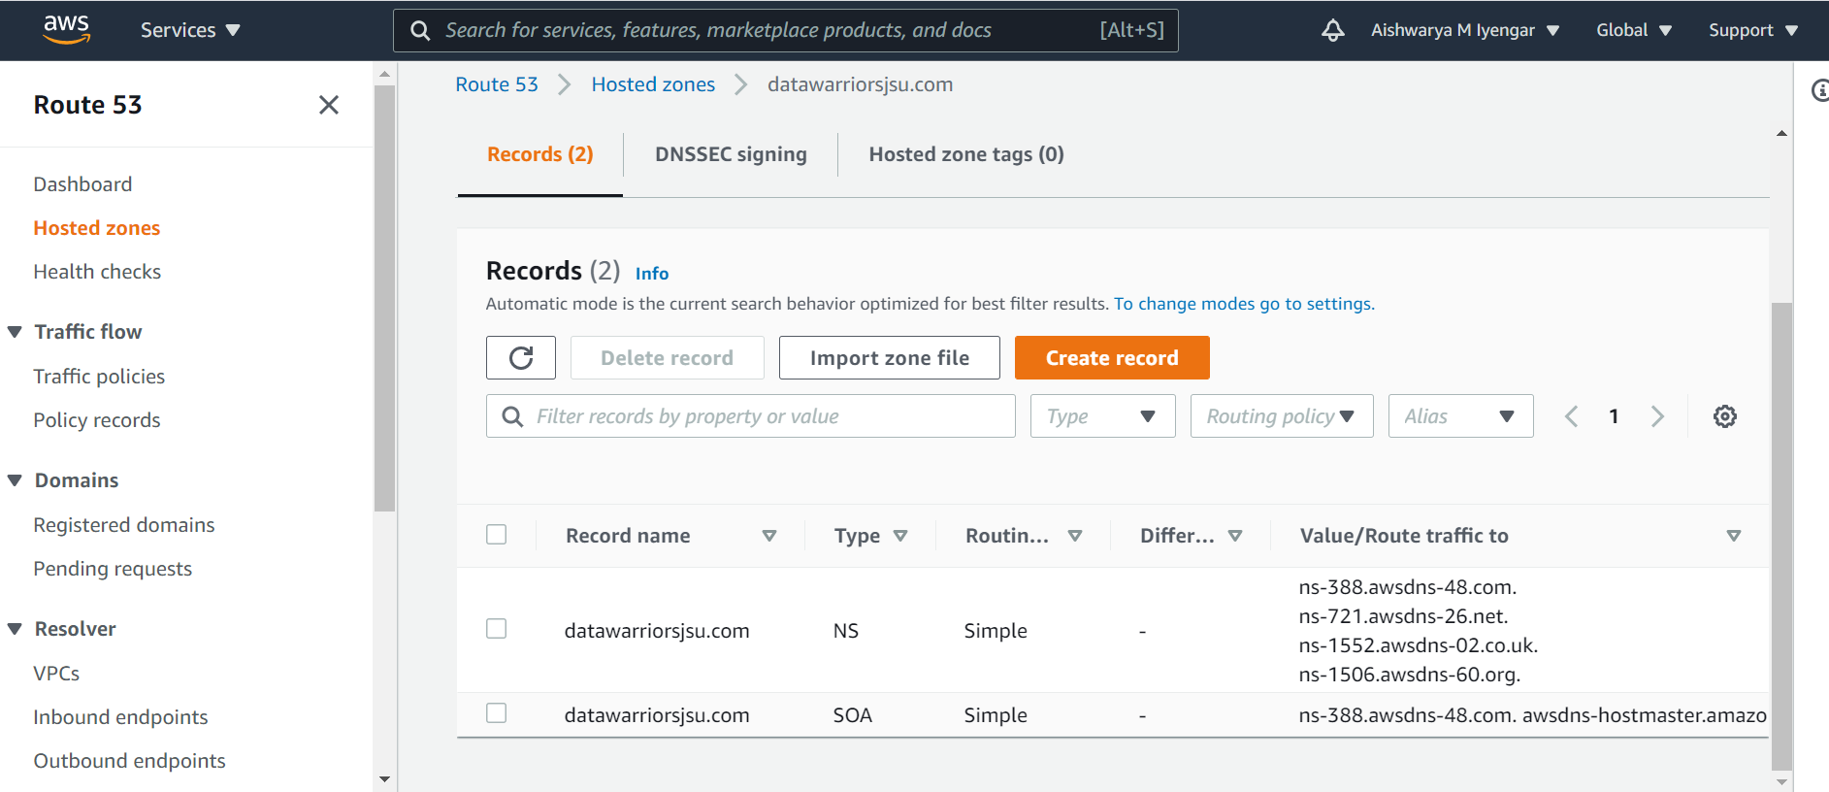

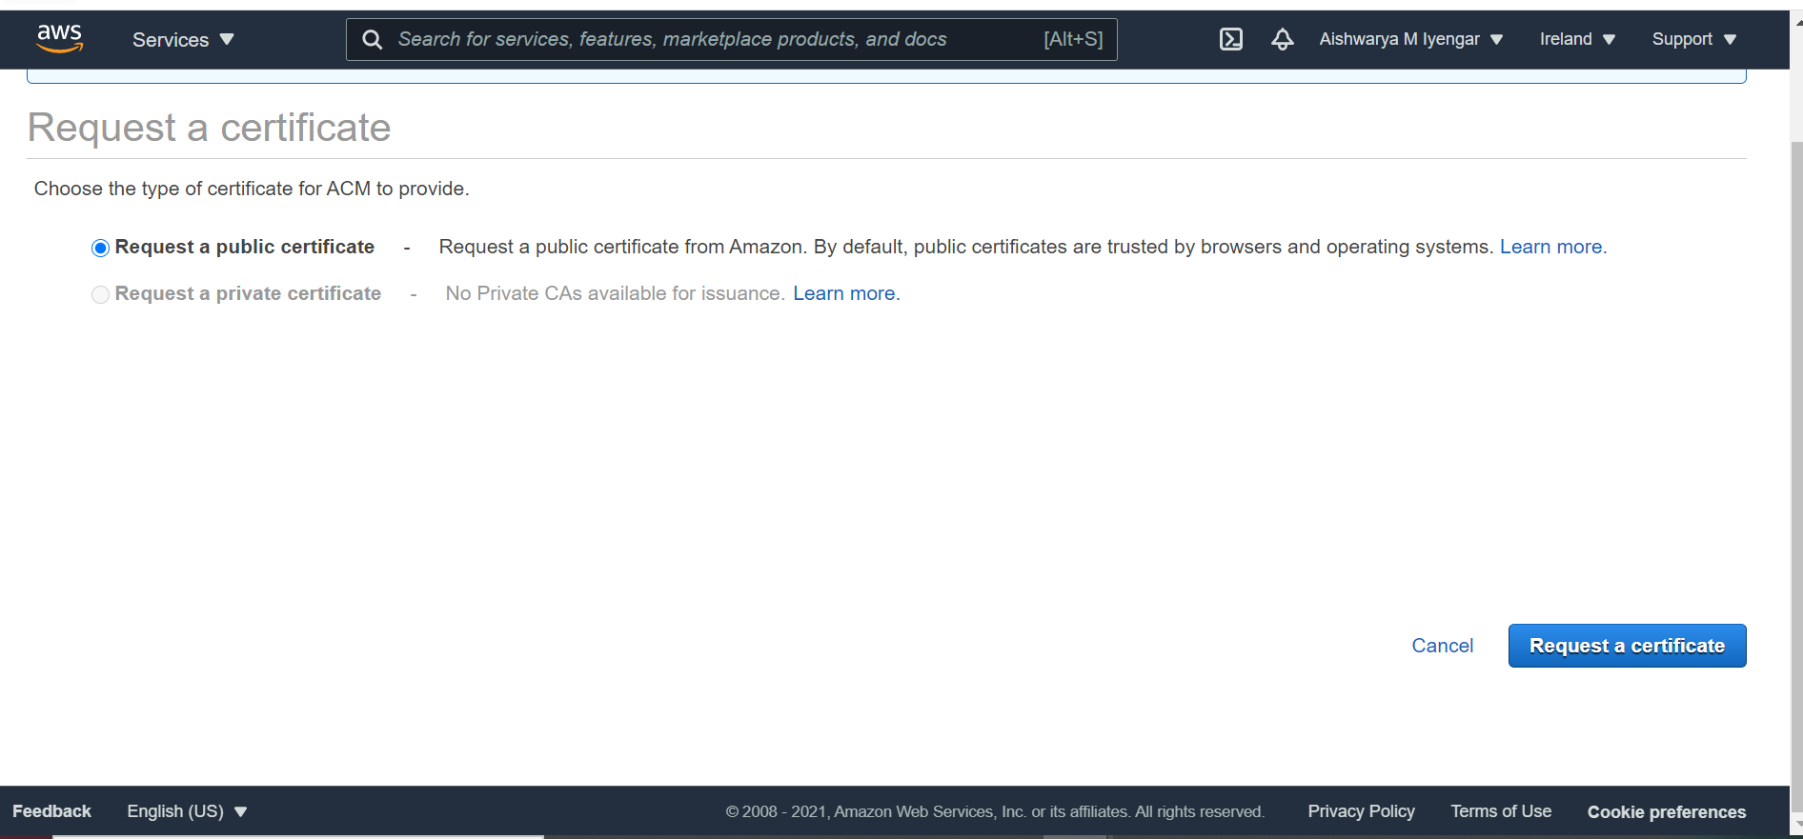

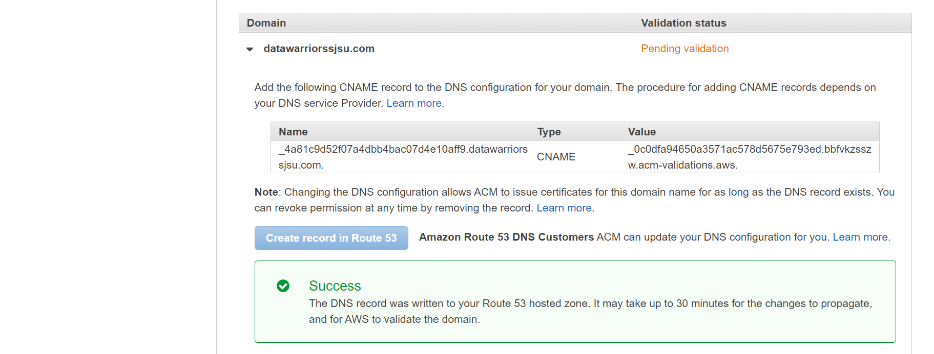

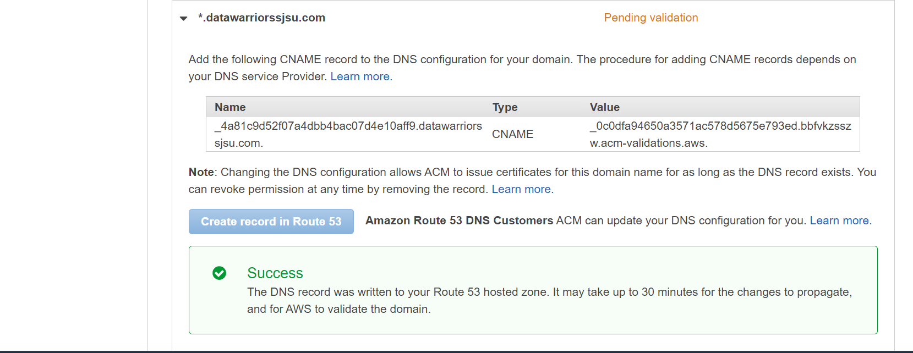

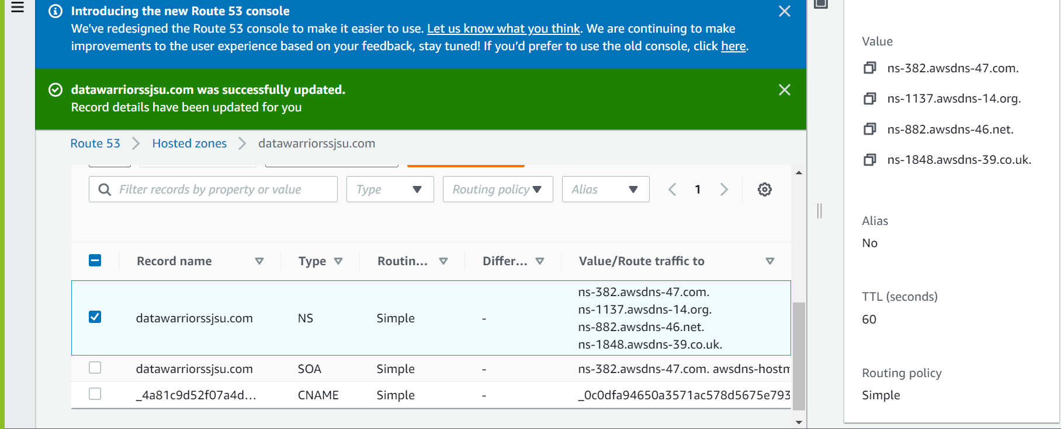

**5.Test failover**

Now head over to **Route53** and select **Health checks**. Within a few minutes, your health check should turn from green to red and display a failure.



